

*Florida International University*

*School of Computing and Information Sciences*

CIS-4911(U01)-Senior Project

***Final Deliverable***

**Dynamic Mathematics Principles**

**Team Members:**

Andres M. Cubas

Ingrid Troche

**Instructor:** Dr.Masoud Sadjadi

**Product Owner:** Mario Eraso

Copyright and trademark notices, restrictions on copying or distributing the documentation, information for contacting the issuing organization (reader’s comments), warranties, contractual obligations or disclaimers, and general warnings and cautions.



***Abstract***

*Dynamic Mathematics Principles is a website where users can experiment with mathematical concepts and principles to spark their curiosity and passion for mathematics. Mathematical applications and modeling will be presented also to show the relevance of various principles in the users' lives. Making this website available will be able to promote mathematical learning by allowing for an environment of focused on Dynamic Mathematical learning. In addition this website will collect feedback about user experience and suggestions for future reference.*

*This document includes details about the current system, purpose of new system, the newly developed user stories implemented during the last sprints of version 1.0, an in-depth explanation of the software architecture used, the design patterns implemented to enhance the solution, testing criteria, analysis, UML diagrams, a breakdown of all sprint reviews meetings, and sprint sprint retrospective reviews. In conclusion this document is guide that documents all the work done for version 1.0. In addition, serves as a structured- guide for future developers so they can quickly become familiar with the system.*

Table of Contents



Introduction 7

Purpose of New System 8

User Stories 8

Implemented User Stories 8

Pending User Stories 18

Project Plan 19

Hardware and Software Resources 19

Sprints Plan 20

Sprint 1 20

Sprint 2 23

Sprint 3 26

Sprint 4 28

Sprint 5 32

Sprint 6 35

Sprint 7 38

System Design 40

Architectural Patterns 41

System and Subsystem Decomposition 42

Deployment Diagram 44

Design Patterns 45

Glossary 101

Appendix 102

Appendix A - UML Diagrams 102

Static UML Diagrams 102

Dynamic UML Diagrams 104

User Story#702 - Search 112

Appendix B - User Interface Design 131

Appendix C - Sprint Review Reports 144

References 152

**Introduction**

This document gives some background introduction about Dynamics Mathematics Principles. This chapter includes the current System of Dynamic Mathematics Principles as well as the new version of Dynamics Mathematics, version 1.0. This document is divided into the following sections: User stories, which include information about the user stories. Project Plan includes which covers details about how the work of the project was planned. System Design includes information about architectural patterns, system, subsystem, deployment diagram, and design patterns. The system validation section describes the test used in order to validate the system. The glossary, which covers key terms used in the document. In addition, appendix section, which includes the UML, diagrams, sprint reviews reports, and retrospective reports. The references section, which has all of this document references.

**CURRENT SYSTEM**

There is no current system that provides this kind of functionality in FIU to the public. Currently the teaching methods used are typically passive abstract learning for enrolled college students. The limitations of this learning process are the lack of active engagement and as a consequence students move on without full understanding of the subject, closing their doors to great opportunities out there. This website will be created to increase the user opportunity of understanding mathematical knowledge.

There are no previous versions of this system. This project will be initial code base of the system.

## Purpose of New System

The purpose of the new system is to redefine teaching strategies by creating a dynamic interaction between the system and the user. This approach will ensure that our costumer is engage with our program and as a result gain a full understanding of the material and change their perspectives towards mathematics. This system will have a large impact on users and education wise.

# User Stories

This section will includes Dynamic Mathematics Principles user stories. In the following sections, we will cover to all the user stories obtained during the meetings with the product owners and the features that were discussed. The implemented users stories include all user stories implemented during the semester along with their corresponding related task and acceptance criteria. Then we will include all pending user stories for next product release.

## 

## Implemented User Stories

**User Story # 666 - Register Account**

***User Story Description:*** As a user, I would like to see a “register” link, in the homepage, in order to create an account.

***Acceptance Criteria:***

* Create a page in the web to retrieve the account information
* Create a database cell in a table to save user's information
* Display the status of the completed registration

**User Story #668 - Login**

***User Story Description:*** As a user, I would like to see a “sign in ” link, in the website when I’m not logged in to my account.

***Acceptance Criteria:***

* Dynamath homepage contains a “login” link
* The user should be able to access full features form dynamath website
* Create a transition link between “login” and “logout”
* The servers send back to the user approval or access denial to the user

**User Story # 672 -Logout**

***User Story Description:*** As a user, I would like to see a “ logout ” link, in the website in order to terminate the session.

***Acceptance Criteria:***

* A logged-in user is removed from the user account state
* Create a link in all pages for login-out for users in user account state
* The servers sends back a confirmation logged out message to the user

**User Story #694 - Create Guest Session**

***User Story Description:*** As a user, I would like to see a “Guest” link to try out the website in order to access activities.

***Acceptance Criteria:***

* Create a link on the homepage for users that are not logged in to an account that would start a session with the website to access activities

**User Story #671 - Modify Account**

***User Story Description:*** As a sign in user, I would like to see a “settings” link in order to change or update user information.

***Acceptance Criteria:***

* A user in the user account state has access to the settings link
* Allow modification and recording of new account information

**User Story #673 - Delete Account**

***User Story Description:*** As a sign in user, I would like to delete account in order to remove my information from the system.

***Acceptance Criteria:***

* Delete cell from the database cell table corresponding from the user account
* Create a link to attempt to delete the account’
* To prompt the user if he/she wants to delete the account

**User Story #674 - Reset Password**

***User Story Description:*** As a sign in user, I would like to have access to a “reset password” in order to recover or update password.

***Acceptance Criteria:***

* Update cell table from the database for the corresponding user
* Create a link to attempt to recover the password
* Send an email to the user for resetting password.

**User Story #683 - Select Activity**

***User Story Description:*** As a user, I would like to click on an “activities” link in order to access a learning activity.

***Acceptance Criteria:***

* Redirect user to the specified activity

**User Story # 684 - Create survey**

***User Story Description:*** As a user, I would like to receive a survey after a specific amount of activities completed in order to review the effectiveness of the activities.

***Acceptance Criteria:***

* At least five questions per survey
* Send pre and post survey questions to users in order to capture user learning experience

**User Story #685 - Display Solutions**

***User Story Description:*** As a user, I would like to be able to access a link that redirect user to the solutions page in order to review answers.

***Acceptance Criteria:***

* There is a link that takes the user to the corresponding solution page

**User Story #702 - Search**

***User Story Description:*** As a user, I would like to search would like to search the website with keywords to help me navigate to desired areas of the website.

***Acceptance Criteria:***

* A search bar will be implemented in the header of each page in the website
* A search engine will be created to come up with the best results for the keywords
* A search page will be created to display the the search results

**User Story #703 - Verify Account**

***User Story Description:*** As a user, I would like to search would like to search the website with keywords to help me navigate to desired areas of the website.

***Acceptance Criteria:***

* A search bar will be implemented in the header of each page in the website
* A search engine will be created to come up with the best results for the keywords
* A search page will be created to display the the search results

**User Story #671 - Modify Account**

***User Story Description:*** As a user, I would like to be able to click on modify account link we to modify my account.

***Acceptance Criteria:***

* A user in the user account state has access to the settings link
* Create settings page
* Allow modification and recoding of new account information

**User Story #730 - Create Suggestions Link**

***User Story Description:*** As a user, I would like to be able to click on suggestion link in order to add suggestion and contact the administrator of the website

***Acceptance Criteria:***

* A user has access to the suggestion link
* Allow the user recording of data by sending suggestions to the administrator

**User Story #731 - Create About us link**

***User Story Description:*** As a user, I would like to be able to click on a about us link to know about the school and the program

***Acceptance Criteria:***

* A user has access to about us link
* A user is able to review information about us

**User Story # 684 - Create fun-fact Link**

***User Story Description:*** As a user, I would like to fun-facts activities in order to keep interacting with the system and enjoy other features of the applications to benefit my mathematical skills

***Acceptance Criteria:***

* A user has access to the fun-facts activities
* A user can interact with the fun-facts activities

**User Story # 780 -Main page**

***User Story Description:*** As a user, I would like to be able to click on modify account link we to modify my account.

***Acceptance Criteria:***

* A user has access the main page
* A user has access to different components displayed on the main page

**User Story # 737 -Fun-facts page: Infinity**

***User Story Description:*** As a user, I would like to fun-facts activities in order to keep interacting with the system and enjoy other features of the applications to benefit my mathematical skills

***Acceptance Criteria:***

* A user has access to a fun-facts page called infinity

**User Story # 739 -Archimedes Questionnaires**

***User Story Description:*** As a user, I would like to fun-facts activities in order to keep interacting with the system and enjoy other features of the applications to benefit my mathematical skills

***Acceptance Criteria:***

* A user receives file in order to complete questionnaire related to the activity
* A user can answer the questionnaire
* Answers would be automatically saved into the database

**User Story #741 - Create Rating**

***User Story Description:*** As a user, I would like to be able to rate my favorite activities ***Acceptance Criteria:***

* A user has access to a link in order to start rating
* A user is able to rate activity from 1 to 10
* A user is able to submit result to our database.

**User Story #742 -Visitor Counter**

***User Story Description:*** As a user, I would like to check the popularity of the website.

***Acceptance Criteria:***

* A user has access to view the popularity of the website

**User Story #743 - Password Hashing**

***User Story Description:*** As a user, I would like to have my personal password secure.

***Acceptance Criteria:***

* User password is successfully saved in the database
* User password is successfully encrypted into the database

**User Story #732 - Dynamic Activity Triangle Area**

***User Story Description:*** As a user, I would like an interactive activity that allows me to experience and discover the notion of invariant geometry.

***Acceptance Criteria:***

* Created an interactive java application.
* Research learning and cognition methods
* Apply different scenarios for different interactions
* Implement java sketchpad framework
* Create front end for the activity page

**User Story #738 - Dynamic Activity Infinity**

***User Story Description:*** *As a user, I would like an interactive activity that allows me to experience and discover the notion of infinity and the different ways to understand it.*

***Acceptance Criteria:***

* Created an interactive java application.
* Research learning and cognition methods
* Apply different scenarios for different interactions
* Implement java sketchpad framework
* Create front end for the activity page

**User Story #744 - Create Archimedes quiz**

***User Story Description:*** *As a user, I would like to test my knowledge by receiving a quiz at the end of the activity*

***Acceptance Criteria:***

* Create a table into the database to store questions
* Create a table to store the answers
* Create front end
* Create Backend

**User Story #745 - Create Carl Frederich Quiz**

***User Story Description:****As a user, I would like to test my knowledge by receiving a quiz at the end of the activity.*

***Acceptance Criteria:***

* Create a table into the database to store questions
* Create a table to store the answers
* Create front end
* Create Backend

**User Story #746** **-Create Invariant Geometry Quiz**

***User Story Description****: As a user, I would like to test my knowledge by receiving a quiz at the end of the activity.*

***Acceptance Criteria:***

* Create a table into the database to store questions
* Create a table to store the answers
* Create frontend
* Create Backend

**User Story #747 -Infinity Activity Quiz**

***User Story Description:*** *As a user, I would like to test my knowledge by receiving a quiz at the end of the activity.*

***Acceptance Criteria:***

* Create a table into the database to store questions
* Create a table to store the answers
* Create frontend
* Create Backend

**User Story #748 -Triangle Activity Quiz**

***User Story Description:*** *As a user, I would like to test my knowledge by receiving a quiz at the end of the activity.*

***Acceptance Criteria:***

* Create a table into the database to store questions
* Create a table to store the answers
* Create frontend
* Create Backend

**User Story #750 -Create Activity hints**

***User Story Description:*** *As a user, I would like access hints when solving an activity.*

***Acceptance Criteria:***

* Create a table to store the hints
* Create frontend
* Create Backend

**User Story #750 -Create Activity hints**

***User Story Description:*** *As a user, I would like access hints when solving an activity.*

***Acceptance Criteria:***

* Create a table to store the hints
* Create frontend
* Create Backend

**User Story #752 -Create Activity hints**

***User Story Description:*** *As a user, I would like access hints when solving an activity.*

***Acceptance Criteria:***

* Create a table to store the hints
* Create frontend
* Create Backend

**User Story #751 -Improve UI**

***User Story Description:*** *As a user, I would like a modern and user friendly interface*

***Acceptance Criteria:***

* Optimize website interface

**User Story #751 -Moving website to server**

***User Story Description:*** *As a user, I would like to access the website live, rather than in a testing environment.*

***Acceptance Criteria:***

* Moving application to server

## Pending User Stories

**User Story # X - Story Name**

Text of the story.

…

# Project Plan

This chapter covers DMP 1.0 project planning. First, we include Grantt chart and a list of all software and hardware requirements needed in order to develop DMP system. Concluding, with the work breakdown that shows the identification task, milestones along with their dependencies.

## Hardware and Software Resources

**Software**

* phpmyadmin
* Mingle
* GitHub
* Google drive
* Git
* Gmail
* StartUML
* Visio2013
* Sublime
* Visual Studios

**Hardware**

* Computer that has a 2.2 GHz processor
* Computer that has a 2.3 GHz processor
* 4GB memory of available hard disk space
* 8GB memory of available hard disk space

**Other Devices:**

**Input Devices:**

* Keyboard - Standard Keyboard
* Mouse- Track pad mouse

**Output Devices:**

Monitor Display - 13 inch Intel HD graphics 3000 384 MB

## Sprints Plan

For each sprint, list the user stories selected for implementation in descending order of priority.

### 

### Sprint 1

(08/24/2015 - 09/11/2015)

**User Story # 666 - Register Account**

***Tasks***

* Create documentation
* Dynamath homepage contains a “Register Account” link
* Create database to store data from user
* Create backend registration system
* Create Register Account sequence diagram
* Create a table on the database for register account
* Testing

***Acceptance Criteria***

* Create a page in the web to retrieve the account information
* Create a database cell in a table to save user's information
* Display the status of the completed registration
* Create a transition link between the home screen and registration

***Modeling***

Refer to UML diagrams in Appendix A that were created or modified to model the functionality that will be implemented in this sprint.

**User Story # 694 - Create Guest Session**

***Tasks***

* Create Guest User Account sequence diagram
* Create database cell table on the database for registered users.
* Testing
* Update documentation

***Acceptance Criteria***

* Dynamath homepage contains a “guest user” link
* The user should be able to access some features form dynamath website
* Create a transition link between “guest user” and “register account”

***Modeling***

Refer to UML diagrams in Appendix A that were created or modified to model the functionality that will be implemented in this sprint.

**User Story # 668 - Create Sign In**

***Tasks***

* Create login sequence diagram
* Create sign in backend by validating user credentials
* The collection of tasks of all sprints defines the scope of the system
* Test code

***Acceptance Criteria***

* Dynamath homepage contains a “login” link
* The user should be able to access full features form dynamath website
* Create a transition link between “login” and “logout”
* The servers send back to the user approval or access denial to the user

***Modeling***

Refer to UML diagrams in Appendix A that were created or modified to model the functionality that will be implemented in this sprint.

**User Story # 672 - Create Logout**

***Tasks***

* Create Log out sequence diagram
* Create logout backend
* Test code

***Acceptance Criteria***

* Dynamath homepage should contain a “logout” link
* Create a transition link between “logout” and “login”
* A logged-in user is removed from the user account state
* Create a link in all pages for logging-out for users in user account state
* The servers send back to the user la confirmation logged out message

***Modeling***

Refer to UML diagrams in Appendix A that were created or modified to model the functionality that will be implemented in this sprint.

### Sprint 2

(09/14/2015 - 09/25/2015)

**User Story # 683 - Select Activity**

***Tasks***

* Create Select Activity sequence diagram
* Create database cell table on the database for activities
* Testing
* Update documentation

***Acceptance Criteria***

* Dynamath homepage contains a “Activity” link
* Create a transition link between “Activity” and “Logout”
* User enters to his/her account in order to complete an activity

***Modeling***

Refer to UML diagrams in Appendix A that were created or modified to model the functionality that will be implemented in this sprint.

**User Story # 674 - Reset Password**

***Tasks***

* Create Reset Password sequence diagram
* Update the cell on the database table
* Testing
* Update documentation

***Acceptance Criteria***

* Dynamath homepage contains a “reset password” link
* A reset password link must be embedded into the login page that initiates the user story
* A reset password page must be made to retrieve the username associated to the account of the password to be reset
* The system must be able to send a token link via email to verify the user’s identity
* The token link must route the user to a page on the site to input the the new password and confirm it.

***Modeling***

Refer to UML diagrams in Appendix A that were created or modified to model the functionality that will be implemented in this sprint.

**User Story # 702 - Search**

***Tasks***

* Create Search sequence diagram
* Create the backend for searchbar
* Testing
* Update documentation

***Acceptance Criteria***

* A search bar will be implemented in the header of each page in the website
* A search engine will be created to come up with the best results for the keywords
* A search page will be created to display the the search results

***Modeling***

Refer to UML diagrams in Appendix A that were created or modified to model the functionality that will be implemented in this sprint.

**User Story #703 - Verify Account**

***Tasks***

* Create verify account sequence diagram
* Create the backend for verify account
* Testing
* Update documentation

***Acceptance Criteria***

* After registration, an email will be sent to the account’s email with a link to verify the email
* A link and corresponding page should be created displaying the confirmation of verifying the account.
* The database should contain an authentication code for the verification page.

***Modeling***

Refer to UML diagrams in Appendix A that were created or modified to model the functionality that will be implemented in this sprint.

**User Story # 671 - Modify Account**

***Tasks***

* Create Modify Account sequence diagram
* Update cell table on the database for registered users.
* Testing
* Update documentation

***Acceptance Criteria***

* Dynamath homepage contains a “modify account” link
* A user in the user account state has access to the settings link
* allow modification and recoding of new account information

***Modeling***

Refer to UML diagrams in Appendix A that were created or modified to model the functionality that will be implemented in this sprint.

### Sprint 3

(09/25/2015 - 10/09/2015)

**User Story # 671 - Modify Account**

***Tasks***

* Create Modify Account sequence diagram
* Update cell table on the database for registered users.
* Testing
* Update documentation

***Acceptance Criteria***

* Dynamath homepage contains a “modify account” link
* A user in the user account state has access to the settings link
* allow modification and recoding of new account information

***Modeling***

Refer to UML diagrams in Appendix A that were created or modified to model the functionality that will be implemented in this sprint.

**User Story #730 - Create Suggestions Link**

***Task***

* Create sequence diagram
* Create frontend and backend
* Testing
* Update documentation

***Acceptance Criteria:***

* A user has access to the suggestion link
* Allow the user recording of data by sending suggestions to the administrator

***Modeling***

Refer to UML diagrams in Appendix A that were created or modified to model the functionality that will be implemented in this sprint.

**User Story #731 - Create About Us link**

***Task***

* Create sequence diagram
* Create frontend and backend
* Testing
* Update documentation

***Acceptance Criteria:***

* A user has access to about us link
* A user is able to review information about us

***Modeling***

Refer to UML diagrams in Appendix A that were created or modified to model the functionality that will be implemented in this sprint.

**User Story # 684 - Create fun-fact Link**

***Task***

* Create sequence diagram
* Create frontend and backend
* Testing
* Update documentation

***Acceptance Criteria:***

* A user has access to the fun-facts activities
* A user can interact with the fun-facts activities

***Modeling***

Refer to UML diagrams in Appendix A that were created or modified to model the functionality that will be implemented in this sprint.

### Sprint 4

( 10/09/2015- 10/23/2015)

**User Story # 780 -Main page**

***Task***

* Create sequence diagram
* Create Class diagrams
* Create backend
* Testing
* Update documentation

***Acceptance Criteria:***

* A user has access the main page
* A user has access to different components displayed on the main page

***Modeling***

Refer to UML diagrams in Appendix A that were created or modified to model the functionality that will be implemented in this sprint.

**User Story # 684 -Behavioral Survey**

* Create sequence diagram
* Create Class diagrams
* Create backend
* Testing
* Update documentation

***Acceptance Criteria:***

* A user has access to survey link in order to complete a survey.
* A user can enter as a guest to trial the application before creating an account.

***Modeling***

Refer to UML diagrams in Appendix A that were created or modified to model the functionality that will be implemented in this sprint.

**User Story # 735 -Delete Account**

* Create sequence diagram
* Create Class diagrams
* Create backend
* Testing
* Update documentation

***Acceptance Criteria:***

* A user has access to a delete account link
* A user has access to delete his information
* Information get deleted from database

***Modeling***

Refer to UML diagrams in Appendix A that were created or modified to model the functionality that will be implemented in this sprint

**User Story # 737 -Fun-facts page: Infinity**

* Create sequence diagram
* Create Class diagrams
* Create backend
* Testing
* Update documentation

***Acceptance Criteria:***

* A user has access to a fun-facts page called infinity

***Modeling***

Refer to UML diagrams in Appendix A that were created or modified to model the functionality that will be implemented in this sprint.

**User Story # 739 -Archimedes Questionnaires**

* Create sequence diagram
* Create Class diagrams
* Create backend
* Testing
* Update documentation

***Acceptance Criteria:***

* A user receives file in order to complete questionnaire related to the activity
* A user can answer the questionnaire
* Answers get saved into the database

***Modeling***

Refer to UML diagrams in Appendix A that were created or modified to model the functionality that will be implemented in this sprint.

### 

### 

### Sprint 5

(10/26/2015- 11/06/2015)

**User Story # 732 -Dynamic Activity Triangle Area**

***Task***

* Create sequence diagram
* Create backend
* Testing
* Update documentation

***Acceptance Criteria:***

* Created an interactive java application.
* Research learning and cognition methods
* Apply different scenarios for different interactions
* Implement java sketchpad framework
* Create front end for the activity page

***Modeling***

Refer to UML diagrams in Appendix A that were created or modified to model the functionality that will be implemented in this sprint.

**User Story # 738 -Dynamic Activity Infinity**

***Task***

* Create sequence diagram
* Create backend
* Testing
* Update documentation

***Acceptance Criteria:***

* Created an interactive java application.
* Research learning and cognition methods
* Apply different scenarios for different interactions
* Implement java sketchpad framework
* Create front end for the activity page

***Modeling***

Refer to UML diagrams in Appendix A that were created or modified to model the functionality that will be implemented in this sprint.

**User Story # 743 -Password Hashing**

***Task***

* Create backend by adding a hashing function
* Update Database
* Testing

***Acceptance Criteria:***

* Created a hashing function in order to hash password.
* Research about the most efficient way to encrypt passwords
* Testing database by registering new users.

***Modeling***

Refer to UML diagrams in Appendix A that were created or modified to model the functionality that will be implemented in this sprint.

**User Story # 742 -Visitor Counter**

***Task***

* Create backend to add a counter on our main page
* Update Database by creating a new table
* Testing

***Acceptance Criteria:***

* Created a counter to keep of users visiting the website
* Created table in database to record information in the database

***Modeling***

Refer to UML diagrams in Appendix A that were created or modified to model the functionality that will be implemented in this sprint.

**User Story # 741 - Create Rating**

***Task***

* Create backend
* Front end
* Added table in database to record ratings
* Testing
* Sequence diagram

***Acceptance Criteria:***

* Created a table in the database to record ratings
* Created frontend and backend

***Modeling***

Refer to UML diagrams in Appendix A that were created or modified to model the functionality that will be implemented in this sprint.

### 

### Sprint 6

(11/06/2015- 11/20/2015)

**User Story # 744 - Create Archimedes Quiz**

***Task***

* Create sequence diagram
* Create backend
* Testing
* Update documentation
* Add table on database

***Acceptance Criteria:***

* Add table on the database to store response and add questions
* Create back end for the quiz
* Create front end for the activity page

***Modeling***

Refer to UML diagrams in Appendix A that were created or modified to model the functionality that will be implemented in this sprint.

**User Story # 745 - Create Carl Federich Quiz**

***Task***

* Create sequence diagram
* Create backend
* Testing
* Update documentation
* Add table on database

***Acceptance Criteria:***

* Add table on the database to store response and add questions
* Create back end for the quiz
* Create front end for the activity page

***Modeling***

Refer to UML diagrams in Appendix A that were created or modified to model the functionality that will be implemented in this sprint.

**User Story # 744 - Create Invariant Geometry Quiz**

***Task***

* Create sequence diagram
* Create backend
* Testing
* Update documentation
* Add table on database

***Acceptance Criteria:***

* Add table on the database to store response and add questions
* Create back end for the quiz
* Create front end for the activity page

***Modeling***

Refer to UML diagrams in Appendix A that were created or modified to model the functionality that will be implemented in this sprint.

**User Story # 747 -Create Infiniti Activity Quiz**

***Task***

* Create sequence diagram
* Create backend and frontend
* Testing
* Update documentation

***Acceptance Criteria:***

* Add table on the database to store response and add questions
* Create back end for the quiz
* Create front end for the activity page

***Modeling***

Refer to UML diagrams in Appendix A that were created or modified to model the functionality that will be implemented in this sprint.

**User Story # 748 - Create Triangle Activity Quiz**

***Task***

* Create sequence diagram
* Create backend
* Create frontend
* Update documentation

***Acceptance Criteria:***

* Add table on the database to store response and add questions
* Create back end for the quiz
* Create front end for the activity page

***Modeling***

Refer to UML diagrams in Appendix A that were created or modified to model the functionality that will be implemented in this sprint.

### 

### Sprint 7

(11/23/2015- 12/04/2015)

**User Story # 750 - Create Activity hints**

***Task***

* Create sequence diagram
* Create backend
* Create frontend
* Update documentation

***Acceptance Criteria:***

* Add table on the database to store response and add hints
* Create back end for hints
* Create front end for hints

***Modeling***

Refer to UML diagrams in Appendix A that were created or modified to model the functionality that will be implemented in this sprint.

**User Story # 752 - Create Activity Hints**

***Task***

* Create sequence diagram
* Create backend
* Create frontend
* Update documentation

***Acceptance Criteria:***

* Add table on the database to store response and add hints
* Create back end for hints
* Create front end for hints

***Modeling***

Refer to UML diagrams in Appendix A that were created or modified to model the functionality that will be implemented in this sprint.

**User Story # 751 - Improve UI**

***Task***

* Optimize user website interface
* Optimize code

***Acceptance Criteria:***

* Update documentation

***Modeling***

Refer to UML diagrams in Appendix A that were created or modified to model the functionality that will be implemented in this sprint.

**User Story # 749 - Moving website to server**

***Task***

* Change values in the system depends on the address name of the website

***Acceptance Criteria:***

* Change values in the system depends on the address name of the website

***Modeling***

Refer to UML diagrams in Appendix A that were created or modified to model the functionality that will be implemented in this sprint.

# System Design

This chapter gives a high level description of the system design for Dynamic Mathematic Principles application. It starts by giving an overview of the system by describing the architectural patterns being used for this system. Then it explains how the system is decomposed in the different subsystems.

**Overview**

Dynamic Mathematics Principles has been developed based on Model-View-Controller(MVC).This architecture separates the representation of data(view), the logic of the system(controller) and the database (model).

## Architectural Patterns

The architectural pattern used in this project is the Model-View-Controller (MVC).

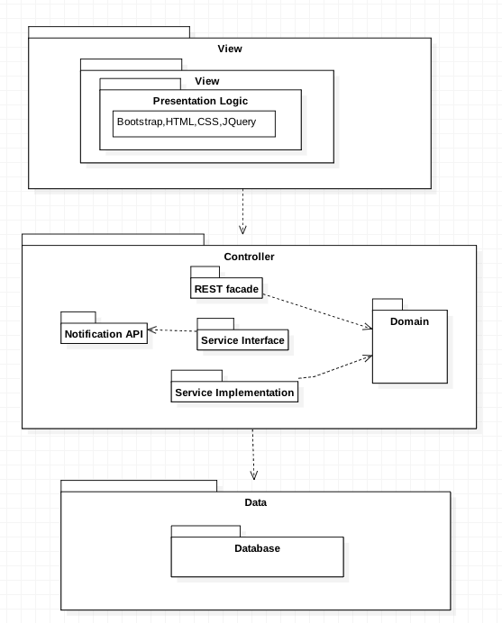

Figure #1.1 - Architecture Diagram

## System and Subsystem Decomposition

**DMP View**

This subsystem has all forms that are presented to the user. This Subsystem varies its presentation according to who is interacting with it, no all the actors are going to have the same options. Once the user make a request through this subsystem the request is passed to the controller subsystem.

**DMP Controller**

This subsystem is in charge of the logic of the system. Most of the data that is needed to be stored or displayed goes through the controller.

**DMP Model**

Provides a way to interact with the data so it can be stored or retrieved from the repository. It receives request from controller and performs it by requesting to the database.

**DMP Database**

This is the module where all the information get stored.

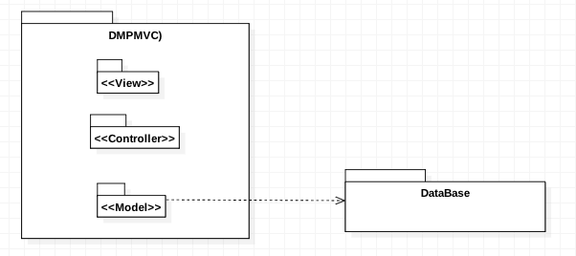

Figure #1.2- Subsystem Diagram

## Deployment Diagram

Below is the system deployment diagram showing how the system is implemented

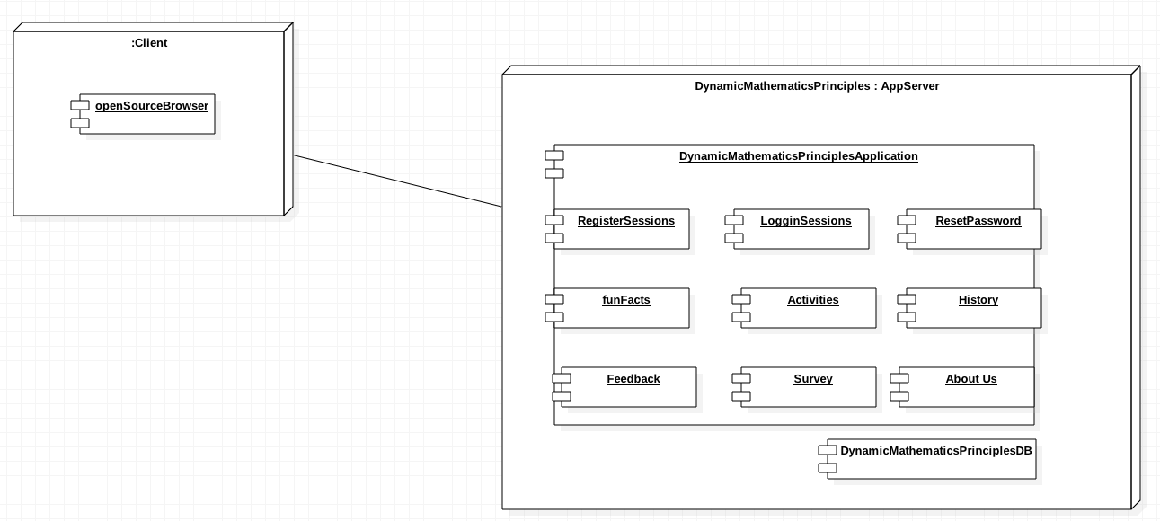

Figure 1.3# - Deployment Diagram

## Design Patterns

The design pattern chosen for dynamic Mathematics Principle was Client-Server. Client-Server is use to integrate the client and the servers. The Client requests information stored on the server. The server response client request by giving the client the information requested. Servers wait for interactions from the client. The client is not aware of how the server executes the request; instead, it understands the response based on a well known application protocol.

Client-Server pattern assist with security by minimizing the amount of interaction users can have with critical features of the system.

**System Validation**

This section includes all the testing completed on Dynamic Mathematics Principles during its implementation. The following is a list of the test cases done to the application

**User Story # 666- Register Account**

|  |  |
| --- | --- |
| Test Case ID | **DMP 666- SUNNY** |
| Purpose | To validate registration form |
| Preconditions | The user needs a valid email account,  Password 7 or more characters long |
| Input | Click on register |
| Expected Result | Successfully creates an account for the user |
|  | <?xml version="1.0" encoding="UTF-8"?>  <!DOCTYPE html PUBLIC "-//W3C//DTD XHTML 1.0 Strict//EN" "http://www.w3.org/TR/xhtml1/DTD/xhtml1-strict.dtd">  <html xmlns="http://www.w3.org/1999/xhtml" xml:lang="en" lang="en">  <head profile="http://selenium-ide.openqa.org/profiles/test-case">  <meta http-equiv="Content-Type" content="text/html; charset=UTF-8" />  <link rel="selenium.base" href="http://localhost/DynaMathVersion1/registrationform.php" />  <title>New Test</title>  </head>  <body>  <table cellpadding="1" cellspacing="1" border="1">  <thead>  <tr><td rowspan="1" colspan="3">New Test</td></tr>  </thead><tbody>  <tr>  <td>open</td>  <td>/DynaMathVersion1/registrationform.php</td>  <td></td>  </tr>  <tr>  <td>type</td>  <td>id=inputfn3</td>  <td>ingrid</td>  </tr>  <tr>  <td>type</td>  <td>name=email</td>  <td>itroc001@fiu.edu</td>  </tr>  <tr>  <td>type</td>  <td>id=inputGender2</td>  <td>f</td>  </tr>  <tr>  <td>type</td>  <td>id=inputUsername2</td>  <td>ingrid</td>  </tr>  <tr>  <td>type</td>  <td>id=inputPassword3</td>  <td>123456789</td>  </tr>  <tr>  <td>type</td>  <td>id=inputPassword4</td>  <td>123456789</td>  </tr>  <tr>  <td>clickAndWait</td>  <td>name=submit</td>  <td></td>  </tr>  <tr>  <td>open</td>  <td>http://www.gmail.com</td>  <td></td>  </tr>  <tr>  <td>type</td>  <td>id=Email</td>  <td>itroc001@fiu.edu</td>  </tr>  <tr>  <td>click</td>  <td>id=next</td>  <td></td>  </tr>  <tr>  <td>type</td>  <td>id=Passwd</td>  <td>passwd</td>  </tr>  <tr>  <td>clickAndWait</td>  <td>id=signIn</td>  <td></td>  </tr>  <tr>  <td>click</td>  <td>//span[@id=':2p']/b</td>  <td></td>  </tr>  <tr>  <td>storeText</td>  <td>link=regexp:http://localhost/DynaMathVersion1/emailconfirm.php\*</td>  <td>mylink</td>  </tr>  <tr>  <td>open</td>  <td>${mylink}</td>  <td></td>  </tr>  </tbody></table>  </body>  </html> |

|  |  |
| --- | --- |
| Test Case ID | **DMP 666- RAINY** |
| Purpose | To validate registration form |
| Preconditions | The user needs a valid email account,  Password 7 or more characters long |
| Input | Click on register |
| Expected Result | User is not able to create account |
|  | <?xml version="1.0" encoding="UTF-8"?>  <!DOCTYPE html PUBLIC "-//W3C//DTD XHTML 1.0 Strict//EN" "http://www.w3.org/TR/xhtml1/DTD/xhtml1-strict.dtd">  <html xmlns="http://www.w3.org/1999/xhtml" xml:lang="en" lang="en">  <head profile="http://selenium-ide.openqa.org/profiles/test-case">  <meta http-equiv="Content-Type" content="text/html; charset=UTF-8" />  <link rel="selenium.base" href="http://localhost/DynaMathVersion1/registrationform.php" />  <title>New Test</title>  </head>  <body>  <table cellpadding="1" cellspacing="1" border="1">  <thead>  <tr><td rowspan="1" colspan="3">New Test</td></tr>  </thead><tbody>  <tr>  <td>open</td>  <td>/DynaMathVersion1/registrationform.php</td>  <td></td>  </tr>  <tr>  <td>type</td>  <td>id=inputfn3</td>  <td>ingrid</td>  </tr>  <tr>  <td>type</td>  <td>name=email</td>  <td>itroc001@fiu.edu</td>  </tr>  <tr>  <td>type</td>  <td>id=inputGender2</td>  <td>f</td>  </tr>  <tr>  <td>type</td>  <td>id=inputUsername2</td>  <td>ingrid</td>  </tr>  <tr>  <td>type</td>  <td>id=inputPassword3</td>  <td>123456789</td>  </tr>  <tr>  <td>type</td>  <td>id=inputPassword4</td>  <td>123456789</td>  </tr>  <tr>  <td>clickAndWait</td>  <td>name=submit</td>  <td></td>  </tr>  <tr>  <td>open</td>  <td>http://www.gmail.com</td>  <td></td>  </tr>  <tr>  <td>type</td>  <td>id=Email</td>  <td>itroc001@fiu.edu</td>  </tr>  <tr>  <td>click</td>  <td>id=next</td>  <td></td>  </tr>  <tr>  <td>type</td>  <td>id=Passwd</td>  <td>passwd</td>  </tr>  <tr>  <td>clickAndWait</td>  <td>id=signIn</td>  <td></td>  </tr>  <tr>  <td>click</td>  <td>//span[@id=':2p']/b</td>  <td></td>  </tr>  <tr>  <td>storeText</td>  <td>link=regexp:http://localhost/DynaMathVersion1/emailconfirm.php\*</td>  <td>mylink</td>  </tr>  <tr>  <td>open</td>  <td>${mylink}</td>  <td></td>  </tr>  </tbody></table> |

**User Story # - Sign In**

|  |  |
| --- | --- |
| Test Case ID | **DMP 668- SUNNY** |
| Purpose | To validate sign in link |
| Preconditions | The user needs to have a valid account |
| Input | Click on sign in |
| Expected Result | Successfully login the user to his/her profile |
|  | <?xml version="1.0" encoding="UTF-8"?>  <!DOCTYPE html PUBLIC "-//W3C//DTD XHTML 1.0 Strict//EN" "http://www.w3.org/TR/xhtml1/DTD/xhtml1-strict.dtd">  <html xmlns="http://www.w3.org/1999/xhtml" xml:lang="en" lang="en">  <head profile="http://selenium-ide.openqa.org/profiles/test-case">  <meta http-equiv="Content-Type" content="text/html; charset=UTF-8" />  <link rel="selenium.base" href="http://localhost/DynaMathVersion1/index.php" />  <title>New Test</title>  </head>  <body>  <table cellpadding="1" cellspacing="1" border="1">  <thead>  <tr><td rowspan="1" colspan="3">New Test</td></tr>  </thead><tbody>  <tr>  <td>open</td>  <td>/DynaMathVersion1/login.php</td>  <td></td>  </tr>  <tr>  <td>type</td>  <td>id=inputUsername1</td>  <td>ingrid</td>  </tr>  <tr>  <td>clickAndWait</td>  <td>link=exact:Forgot Password? Click Here</td>  <td></td>  </tr>  <tr>  <td>type</td>  <td>name=username</td>  <td>ingrid</td>  </tr>  <tr>  <td>type</td>  <td>name=email</td>  <td>itroc001@fiu.edu</td>  </tr>  <tr>  <td>clickAndWait</td>  <td>name=submit</td>  <td></td>  </tr>  </tbody></table>  </body>  </html> |

|  |  |
| --- | --- |
| Test Case ID | **DMP 668- RAINY** |
| Purpose | To validate sign in link |
| Preconditions | The user needs to have a valid account |
| Input | Click on sign in |
| Expected Result | Access denied |
|  | <?xml version="1.0" encoding="UTF-8"?>  <!DOCTYPE html PUBLIC "-//W3C//DTD XHTML 1.0 Strict//EN" "http://www.w3.org/TR/xhtml1/DTD/xhtml1-strict.dtd">  <html xmlns="http://www.w3.org/1999/xhtml" xml:lang="en" lang="en">  <head profile="http://selenium-ide.openqa.org/profiles/test-case">  <meta http-equiv="Content-Type" content="text/html; charset=UTF-8" />  <link rel="selenium.base" href="http://localhost/DynaMathVersion1/index.php" />  <title>New Test</title>  </head>  <body>  <table cellpadding="1" cellspacing="1" border="1">  <thead>  <tr><td rowspan="1" colspan="3">New Test</td></tr>  </thead><tbody>  <tr>  <td>open</td>  <td>/DynaMathVersion1/login.php</td>  <td></td>  </tr>  <tr>  <td>type</td>  <td>id=inputUsername1</td>  <td>ingrid</td>  </tr>  <tr>  <td>clickAndWait</td>  <td>link=exact:Forgot Password? Click Here</td>  <td></td>  </tr>  <tr>  <td>type</td>  <td>name=username</td>  <td>ingrid</td>  </tr>  <tr>  <td>type</td>  <td>name=email</td>  <td>itroc001@fiu.edu</td>  </tr>  <tr>  <td>clickAndWait</td>  <td>name=submit</td>  <td></td>  </tr>  </tbody></table>  </body>  </html> |

**User Story #672 - Logout**

|  |  |
| --- | --- |
| Test Case ID | **DMP 672- SUNNY** |
| Purpose | To validate logout link |
| Preconditions | The user needs to be logged in to his/her profile |
| Input | Click on logout |
| Expected Result | Successfully logout user from his/her profile |
|  | <?xml version="1.0" encoding="UTF-8"?>  <!DOCTYPE html PUBLIC "-//W3C//DTD XHTML 1.0 Strict//EN" "http://www.w3.org/TR/xhtml1/DTD/xhtml1-strict.dtd">  <html xmlns="http://www.w3.org/1999/xhtml" xml:lang="en" lang="en">  <head profile="http://selenium-ide.openqa.org/profiles/test-case">  <meta http-equiv="Content-Type" content="text/html; charset=UTF-8" />  <link rel="selenium.base" href="http://localhost/DynaMathVersion1/index.php" />  <title>New Test</title>  </head>  <body>  <table cellpadding="1" cellspacing="1" border="1">  <thead>  <tr><td rowspan="1" colspan="3">New Test</td></tr>  </thead><tbody>  <tr>  <td>open</td>  <td>/DynaMathVersion1/index.php</td>  <td></td>  </tr>  <tr>  <td>clickAndWait</td>  <td>link=Sign In</td>  <td></td>  </tr>  <tr>  <td>type</td>  <td>id=inputUsername1</td>  <td>itroc001</td>  </tr>  <tr>  <td>type</td>  <td>id=inputPassword1</td>  <td>123456789</td>  </tr>  <tr>  <td>clickAndWait</td>  <td>css=button.btn.btn-primary</td>  <td></td>  </tr>  <tr>  <td>clickAndWait</td>  <td>link=Logout</td>  <td></td>  </tr>  </tbody></table>  </body>  </html> |

|  |  |
| --- | --- |
| Test Case ID | **DMP 672- RAINY** |
| Purpose | To validate logout link |
| Preconditions | The user needs to be logged in to his/her profile |
| Input | Click on logout |
| Expected Result | Systems fails to logout user from his/her profile |
|  | <?xml version="1.0" encoding="UTF-8"?>  <!DOCTYPE html PUBLIC "-//W3C//DTD XHTML 1.0 Strict//EN" "http://www.w3.org/TR/xhtml1/DTD/xhtml1-strict.dtd">  <html xmlns="http://www.w3.org/1999/xhtml" xml:lang="en" lang="en">  <head profile="http://selenium-ide.openqa.org/profiles/test-case">  <meta http-equiv="Content-Type" content="text/html; charset=UTF-8" />  <link rel="selenium.base" href="http://localhost/DynaMathVersion1/index.php" />  <title>New Test</title>  </head>  <body>  <table cellpadding="1" cellspacing="1" border="1">  <thead>  <tr><td rowspan="1" colspan="3">New Test</td></tr>  </thead><tbody>  <tr>  <td>open</td>  <td>/DynaMathVersion1/index.php</td>  <td></td>  </tr>  <tr>  <td>clickAndWait</td>  <td>link=Sign In</td>  <td></td>  </tr>  <tr>  <td>type</td>  <td>id=inputUsername1</td>  <td>itroc001</td>  </tr>  <tr>  <td>type</td>  <td>id=inputPassword1</td>  <td>123456789</td>  </tr>  <tr>  <td>clickAndWait</td>  <td>css=button.btn.btn-primary</td>  <td></td>  </tr>  <tr>  <td>clickAndWait</td>  <td>link=Logout</td>  <td></td>  </tr>  </tbody></table>  </body>  </html> |

**User Story #674 - Reset Password**

|  |  |
| --- | --- |
| Test Case ID | **DMP 674-SUNNY** |
| Purpose | To validate reset password link |
| Preconditions | The user needs to reset password |
| Input | Click on reset password link |
| Expected Result | Systems successfully resets password |
|  | <?xml version="1.0" encoding="UTF-8"?>  <!DOCTYPE html PUBLIC "-//W3C//DTD XHTML 1.0 Strict//EN" "http://www.w3.org/TR/xhtml1/DTD/xhtml1-strict.dtd">  <html xmlns="http://www.w3.org/1999/xhtml" xml:lang="en" lang="en">  <head profile="http://selenium-ide.openqa.org/profiles/test-case">  <meta http-equiv="Content-Type" content="text/html; charset=UTF-8" />  <link rel="selenium.base" href="http://localhost/DynaMathVersion1/forgot\_pass.php?code=543963&username=ingrid" />  <title>New Test</title>  </head>  <body>  <table cellpadding="1" cellspacing="1" border="1">  <thead>  <tr><td rowspan="1" colspan="3">New Test</td></tr>  </thead><tbody>  <tr>  <td>open</td>  <td>/DynaMathVersion1/</td>  <td></td>  </tr>  <tr>  <td>clickAndWait</td>  <td>link=Sign In</td>  <td></td>  </tr>  <tr>  <td>clickAndWait</td>  <td>link=exact:Forgot Password? Click Here</td>  <td></td>  </tr>  <tr>  <td>type</td>  <td>name=username</td>  <td>ingrid</td>  </tr>  <tr>  <td>type</td>  <td>name=email</td>  <td>itroc001@fiu.edu</td>  </tr>  <tr>  <td>clickAndWait</td>  <td>name=submit</td>  <td></td>  </tr>  <tr>  <td>open</td>  <td>http://www.gmail.com</td>  <td></td>  </tr>  <tr>  <td>type</td>  <td>id=Email</td>  <td>itroc001@fiu.edu</td>  </tr>  <tr>  <td>click</td>  <td>id=next</td>  <td></td>  </tr>  <tr>  <td>type</td>  <td>id=Passwd</td>  <td>passwd</td>  </tr>  <tr>  <td>clickAndWait</td>  <td>id=signIn</td>  <td></td>  </tr>  <tr>  <td>click</td>  <td>//span[@id=':2p']/b</td>  <td></td>  </tr>  <tr>  <td>storeText</td>  <td>link=regexp:http://localhost/DynaMathVersion1/forgot\_pass\*</td>  <td>mylink</td>  </tr>  <tr>  <td>open</td>  <td>${mylink}</td>  <td></td>  </tr>  <tr>  <td>type</td>  <td>name=newpass</td>  <td>123</td>  </tr>  <tr>  <td>type</td>  <td>name=newpass1</td>  <td>123</td>  </tr>  <tr>  <td>clickAndWait</td>  <td>css=input.btn.btn-primary</td>  <td></td>  </tr>  <tr>  <td>assertText</td>  <td>id=container</td>  <td>Your password has been updated Click here to login</td>  </tr>  <tr>  <td>open</td>  <td>http://www.gmail.com</td>  <td></td>  </tr>  <tr>  <td>click</td>  <td>css=span.gb\_Ja.gbii</td>  <td></td>  </tr>  <tr>  <td>clickAndWait</td>  <td>id=gb\_71</td>  <td></td>  </tr>  <tr>  <td>type</td>  <td>id=Passwd</td>  <td>Passwd</td>  </tr>  <tr>  <td>clickAndWait</td>  <td>id=account-chooser-link</td>  <td></td>  </tr>  <tr>  <td>click</td>  <td>id=edit-account-list</td>  <td></td>  </tr>  <tr>  <td>click</td>  <td>id=choose-account-0</td>  <td></td>  </tr>  <tr>  <td>clickAndWait</td>  <td>id=edit-account-list</td>  <td></td>  </tr>  </tbody></table>  </body>  </html> |

|  |  |
| --- | --- |
| Test Case ID | **DMP 674-RAINY** |
| Purpose | To validate reset password link |
| Preconditions | The user needs to reset password |
| Input | Click on reset password link |
| Expected Result | Systems fails to reset user password |
|  | ?xml version="1.0" encoding="UTF-8"?>  <!DOCTYPE html PUBLIC "-//W3C//DTD XHTML 1.0 Strict//EN" "http://www.w3.org/TR/xhtml1/DTD/xhtml1-strict.dtd">  <html xmlns="http://www.w3.org/1999/xhtml" xml:lang="en" lang="en">  <head profile="http://selenium-ide.openqa.org/profiles/test-case">  <meta http-equiv="Content-Type" content="text/html; charset=UTF-8" />  <link rel="selenium.base" href="http://localhost/DynaMathVersion1/forgot\_pass.php?code=543963&username=ingrid" />  <title>New Test</title>  </head>  <body>  <table cellpadding="1" cellspacing="1" border="1">  <thead>  <tr><td rowspan="1" colspan="3">New Test</td></tr>  </thead><tbody>  <tr>  <td>open</td>  <td>/DynaMathVersion1/forgot\_pass.php?code=246225&amp;username=ingrid</td>  <td></td>  </tr>  <tr>  <td>type</td>  <td>name=newpass</td>  <td>12345</td>  </tr>  <tr>  <td>type</td>  <td>xpath=(//input[@name='newpass'])[2]</td>  <td>12345</td>  </tr>  <tr>  <td>clickAndWait</td>  <td>css=input.btn.btn-primary</td>  <td></td>  </tr>  </tbody></table>  </body>  </html> |

**User Story #703 - Verify Account**

|  |  |
| --- | --- |
| Test Case ID | **DMP 703- SUNNY** |
| Purpose | To validate verify account link |
| Preconditions | The user needs to register an account |
| Input | Click on click on email link |
| Expected Result | Successfully send email to the user |
|  | <?xml version="1.0" encoding="UTF-8"?>  <!DOCTYPE html PUBLIC "-//W3C//DTD XHTML 1.0 Strict//EN" "http://www.w3.org/TR/xhtml1/DTD/xhtml1-strict.dtd">  <html xmlns="http://www.w3.org/1999/xhtml" xml:lang="en" lang="en">  <head profile="http://selenium-ide.openqa.org/profiles/test-case">  <meta http-equiv="Content-Type" content="text/html; charset=UTF-8" />  <link rel="selenium.base" href="http://localhost/DynaMathVersion1/registrationform.php" />  <title>New Test</title>  </head>  <body>  <table cellpadding="1" cellspacing="1" border="1">  <thead>  <tr><td rowspan="1" colspan="3">New Test</td></tr>  </thead><tbody>  <tr>  <td>open</td>  <td>/DynaMathVersion1/registrationform.php</td>  <td></td>  </tr>  <tr>  <td>type</td>  <td>id=inputfn3</td>  <td>ingrid</td>  </tr>  <tr>  <td>type</td>  <td>name=email</td>  <td>itroc001@fiu.edu</td>  </tr>  <tr>  <td>type</td>  <td>id=inputGender2</td>  <td>f</td>  </tr>  <tr>  <td>type</td>  <td>id=inputUsername2</td>  <td>ingrid</td>  </tr>  <tr>  <td>type</td>  <td>id=inputPassword3</td>  <td>123456789</td>  </tr>  <tr>  <td>type</td>  <td>id=inputPassword4</td>  <td>123456789</td>  </tr>  <tr>  <td>clickAndWait</td>  <td>name=submit</td>  <td></td>  </tr>  <tr>  <td>open</td>  <td>http://www.gmail.com</td>  <td></td>  </tr>  <tr>  <td>type</td>  <td>id=Email</td>  <td>itroc001@fiu.edu</td>  </tr>  <tr>  <td>click</td>  <td>id=next</td>  <td></td>  </tr>  <tr>  <td>type</td>  <td>id=Passwd</td>  <td>passwd</td>  </tr>  <tr>  <td>clickAndWait</td>  <td>id=signIn</td>  <td></td>  </tr>  <tr>  <td>click</td>  <td>//span[@id=':2p']/b</td>  <td></td>  </tr>  <tr>  <td>storeText</td>  <td>link=regexp:http://localhost/DynaMathVersion1/emailconfirm.php\*</td>  <td>mylink</td>  </tr>  <tr>  <td>open</td>  <td>${mylink}</td>  <td></td>  </tr>  </tbody></table>  </body>  </html> |

|  |  |
| --- | --- |
| Test Case ID | **DMP 703- RAINY** |
| Purpose | To validate verify account |
| Preconditions | The user needs to register an account |
| Input | Click on link provided |
| Expected Result | Fails to send email |
|  | <?xml version="1.0" encoding="UTF-8"?>  <!DOCTYPE html PUBLIC "-//W3C//DTD XHTML 1.0 Strict//EN" "http://www.w3.org/TR/xhtml1/DTD/xhtml1-strict.dtd">  <html xmlns="http://www.w3.org/1999/xhtml" xml:lang="en" lang="en">  <head profile="http://selenium-ide.openqa.org/profiles/test-case">  <meta http-equiv="Content-Type" content="text/html; charset=UTF-8" />  <link rel="selenium.base" href="http://localhost/DynaMathVersion1/registrationform.php" />  <title>New Test</title>  </head>  <body>  <table cellpadding="1" cellspacing="1" border="1">  <thead>  <tr><td rowspan="1" colspan="3">New Test</td></tr>  </thead><tbody>  <tr>  <td>open</td>  <td>/DynaMathVersion1/registrationform.php</td>  <td></td>  </tr>  <tr>  <td>type</td>  <td>id=inputfn3</td>  <td>ingrid</td>  </tr>  <tr>  <td>type</td>  <td>name=email</td>  <td>itroc001@fiu.edu</td>  </tr>  <tr>  <td>type</td>  <td>id=inputGender2</td>  <td>f</td>  </tr>  <tr>  <td>type</td>  <td>id=inputUsername2</td>  <td>ingrid</td>  </tr>  <tr>  <td>type</td>  <td>id=inputPassword3</td>  <td>123456789</td>  </tr>  <tr>  <td>type</td>  <td>id=inputPassword4</td>  <td>123456789</td>  </tr>  <tr>  <td>clickAndWait</td>  <td>name=submit</td>  <td></td>  </tr>  <tr>  <td>open</td>  <td>http://www.gmail.com</td>  <td></td>  </tr>  <tr>  <td>type</td>  <td>id=Email</td>  <td>itroc001@fiu.edu</td>  </tr>  <tr>  <td>click</td>  <td>id=next</td>  <td></td>  </tr>  <tr>  <td>type</td>  <td>id=Passwd</td>  <td>passwd</td>  </tr>  <tr>  <td>clickAndWait</td>  <td>id=signIn</td>  <td></td>  </tr>  <tr>  <td>click</td>  <td>//span[@id=':2p']/b</td>  <td></td>  </tr>  <tr>    </tbody></table>  </body>  </html> |

**User Story #730 - Create Suggestions Link**

|  |  |
| --- | --- |
| Test Case ID | **DMP 730- SUNNY** |
| Purpose | To validate suggestions link |
| Preconditions | The user needs to have a valid account and frequently use the application in order to provide feedback |
| Input | Click on suggestions Link |
| Expected Result | User successfully access the file |
|  | <?xml version="1.0" encoding="UTF-8"?>  <!DOCTYPE html PUBLIC "-//W3C//DTD XHTML 1.0 Strict//EN" "http://www.w3.org/TR/xhtml1/DTD/xhtml1-strict.dtd">  <html xmlns="http://www.w3.org/1999/xhtml" xml:lang="en" lang="en">  <head profile="http://selenium-ide.openqa.org/profiles/test-case">  <meta http-equiv="Content-Type" content="text/html; charset=UTF-8" />  <link rel="selenium.base" href="http://localhost/DynaMathVersion1.3/login.php" />  <title>SuggestionsTestCase</title>  </head>  <body>  <table cellpadding="1" cellspacing="1" border="1">  <thead>  <tr><td rowspan="1" colspan="3">SuggestionsTestCase</td></tr>  </thead><tbody>  <tr>  <td>open</td>  <td>/DynaMathVersion1.3/index.php</td>  <td></td>  </tr>  <tr>  <td>click</td>  <td>link=Dropdown</td>  <td></td>  </tr>  <tr>  <td>clickAndWait</td>  <td>link=Suggestions</td>  <td></td>  </tr>  <tr>  <td>type</td>  <td>id=inputfn3</td>  <td>ingrid</td>  </tr>  <tr>  <td>type</td>  <td>id=inputln4</td>  <td>troche</td>  </tr>  <tr>  <td>type</td>  <td>id=inputemail4</td>  <td>itroc001@fiu.edu</td>  </tr>  <tr>  <td>type</td>  <td>id=area</td>  <td>hshd</td>  </tr>  <tr>  <td>clickAndWait</td>  <td>id=submit</td>  <td></td>  </tr>  <tr>  <td>open</td>  <td>http://www.gmail.com</td>  <td></td>  </tr>  <tr>  <td>type</td>  <td>id=Email</td>  <td>itroc001@fiu.edu</td>  </tr>  <tr>  <td>click</td>  <td>id=next</td>  <td></td>  </tr>  <tr>  <td>type</td>  <td>id=Passwd</td>  <td>passwd</td>  </tr>  <tr>  <td>clickAndWait</td>  <td>id=signIn</td>  <td></td>  </tr>  <tr>  <td>click</td>  <td>css=span[name=&quot;ingrid&quot;]</td>  <td></td>  </tr>  <tr>  <td>click</td>  <td>id=:2j</td>  <td></td>  </tr>  <tr>  <td>click</td>  <td>//div[@id=':5']/div/div/div/div/div/div[2]/div[3]</td>  <td></td>  </tr>  <tr>  <td>click</td>  <td>css=span.gb\_Ja.gbii</td>  <td></td>  </tr>  <tr>  <td>clickAndWait</td>  <td>id=gb\_71</td>  <td></td>  </tr>  <tr>  <td>type</td>  <td>id=Passwd</td>  <td>passwd</td>  </tr>  <tr>  <td>type</td>  <td>id=Passwd</td>  <td>passwd</td>  </tr>  </tbody></table>  </body>  </html> |

|  |  |
| --- | --- |
| Test Case ID | **DMP 730- RAINY** |
| Purpose | To validate suggestions link |
| Preconditions | The user needs to have a valid account and frequently use the application in order to provide feedback |
| Input | Click on suggestions Link |
| Expected Result | Message failed to send. |
|  | <?xml version="1.0" encoding="UTF-8"?>  <!DOCTYPE html PUBLIC "-//W3C//DTD XHTML 1.0 Strict//EN" "http://www.w3.org/TR/xhtml1/DTD/xhtml1-strict.dtd">  <html xmlns="http://www.w3.org/1999/xhtml" xml:lang="en" lang="en">  <head profile="http://selenium-ide.openqa.org/profiles/test-case">  <meta http-equiv="Content-Type" content="text/html; charset=UTF-8" />  <link rel="selenium.base" href="http://localhost/DynaMathVersion1.3/login.php" />  <title>SuggestionsTestCase</title>  </head>  <body>  <table cellpadding="1" cellspacing="1" border="1">  <thead>  <tr><td rowspan="1" colspan="3">SuggestionsTestCase</td></tr>  </thead><tbody>  <tr>  <td>open</td>  <td>/DynaMathVersion1.3/index.php</td>  <td></td>  </tr>  <tr>  <td>click</td>  <td>link=Dropdown</td>  <td></td>  </tr>  <tr>  <td>clickAndWait</td>  <td>link=Suggestions</td>  <td></td>  </tr>  <tr>  <td>type</td>  <td>id=inputfn3</td>  <td>ingrid</td>  </tr>  <tr>  <td>type</td>  <td>id=inputln4</td>  <td>troche</td>  </tr>  <tr>  <td>type</td>  <td>id=inputemail4</td>  <td>itroc001@fiu.edu</td>  </tr>  <tr>  <td>type</td>  <td>id=area</td>  <td>hshd</td>  </tr>  <tr>  <td>clickAndWait</td>  <td>id=submit</td>  <td></td>  </tr>  <tr>  <td>open</td>  <td>http://www.gmail.com</td>  <td></td>  </tr>  <tr>  <td>type</td>  <td>id=Email</td>  <td>itroc001@fiu.edu</td>  </tr>  <tr>  <td>click</td>  <td>id=next</td>  <td></td>  </tr>  <tr>  <td>type</td>  <td>id=Passwd</td>  <td>passwd</td>  </tr>  <tr>  <td>clickAndWait</td>  <td>id=signIn</td>  <td></td>  </tr>  <tr>  <td>click</td>  <td>css=span[name=&quot;ingrid&quot;]</td>  <td></td>  </tr>  <tr>  <td>click</td>  <td>id=:2j</td>  <td></td>  </tr>  <tr>  <td>click</td>  <td>//div[@id=':5']/div/div/div/div/div/div[2]/div[3]</td>  <td></td>  </tr>  <tr>  <td>click</td>  <td>css=span.gb\_Ja.gbii</td>  <td></td>  </tr>  <tr>  <td>clickAndWait</td>  <td>id=gb\_71</td>  <td></td>  </tr>  <tr>  <td>type</td>  <td>id=Passwd</td>  <td>passwd</td>  </tr>  <tr>  <td>type</td>  <td>id=Passwd</td>  <td>passwd</td>  </tr>  </tbody></table>  </body>  </html> |

**User Story #731 - Create About Us link**

|  |  |
| --- | --- |
| Test Case ID | **DMP731 - SUNNY** |
| Purpose | To validate about us link |
| Preconditions | The user needs to be connected to the website |
| Input | Click on about us |
| Expected Result | Successfully display about us page |
|  | <?xml version="1.0" encoding="UTF-8"?>  <!DOCTYPE html PUBLIC "-//W3C//DTD XHTML 1.0 Strict//EN" "http://www.w3.org/TR/xhtml1/DTD/xhtml1-strict.dtd">  <html xmlns="http://www.w3.org/1999/xhtml" xml:lang="en" lang="en">  <head profile="http://selenium-ide.openqa.org/profiles/test-case">  <meta http-equiv="Content-Type" content="text/html; charset=UTF-8" />  <link rel="selenium.base" href="http://localhost/DynaMathVersion1.3/login.php" />  <title>AboutUs</title>  </head>  <body>  <table cellpadding="1" cellspacing="1" border="1">  <thead>  <tr><td rowspan="1" colspan="3">AboutUs</td></tr>  </thead><tbody>  <tr>  <td>open</td>  <td>/DynaMathVersion1.3/aboutUs.php</td>  <td></td>  </tr>  <tr>  <td>clickAndWait</td>  <td>link=Logout</td>  <td></td>  </tr>  <tr>  <td>click</td>  <td>link=Dropdown</td>  <td></td>  </tr>  <tr>  <td>clickAndWait</td>  <td>link=About Us</td>  <td></td>  </tr>  <tr>  <td>clickAndWait</td>  <td>link=Logout</td>  <td></td>  </tr>  <tr>  <td>clickAndWait</td>  <td>css=a[name=&quot;Submit&quot;]</td>  <td></td>  </tr>  <tr>  <td>clickAndWait</td>  <td>link=Logout</td>  <td></td>  </tr>  </tbody></table>  </body>  </html> |

|  |  |
| --- | --- |
| Test Case ID | **DMP731 - RAINY** |
| Purpose | To validate about us link |
| Preconditions | The user needs to be connected to the website |
| Input | Click on about us link |
| Expected Result | Failed to display about us page |
|  | <?xml version="1.0" encoding="UTF-8"?>  <!DOCTYPE html PUBLIC "-//W3C//DTD XHTML 1.0 Strict//EN" "http://www.w3.org/TR/xhtml1/DTD/xhtml1-strict.dtd">  <html xmlns="http://www.w3.org/1999/xhtml" xml:lang="en" lang="en">  <head profile="http://selenium-ide.openqa.org/profiles/test-case">  <meta http-equiv="Content-Type" content="text/html; charset=UTF-8" />  <link rel="selenium.base" href="http://localhost/DynaMathVersion1/login.php" />  <title>AboutUs</title>  </head>  <body>  <table cellpadding="1" cellspacing="1" border="1">  <thead>  <tr><td rowspan="1" colspan="3">AboutUs</td></tr>  </thead><tbody>  <tr>  <td>open</td>  <td>/DynaMathVersion1.3/aboutUs.php</td>  <td></td>  </tr>  <tr>  <td>clickAndWait</td>  <td>link=Logout</td>  <td></td>  </tr>  <tr>  <td>click</td>  <td>link=Dropdown</td>  <td></td>  </tr>  <tr>  <td>clickAndWait</td>  <td>link=About Us</td>  <td></td>  </tr>  <tr>  <td>clickAndWait</td>  <td>link=Logout</td>  <td></td>  </tr>  <tr>  <td>clickAndWait</td>  <td>css=a[name=&quot;Submit&quot;]</td>  <td></td>  </tr>  <tr>  <td>clickAndWait</td>  <td>link=Logout</td>  <td></td>  </tr>  </tbody></table>  </body>  </html> |

**User Story # 743 – Password Hashing**

|  |  |
| --- | --- |
| Test Case ID | **DMP 743- SUNNY** |
| Purpose | To validate password hashing functionality |
| Preconditions | The user needs to create an account |
| Input | Click on register |
| Expected Result | Successfully hash user password |
|  | <?xml version="1.0" encoding="UTF-8"?>  <!DOCTYPE html PUBLIC "-//W3C//DTD XHTML 1.0 Strict//EN" "http://www.w3.org/TR/xhtml1/DTD/xhtml1-strict.dtd">  <html xmlns="http://www.w3.org/1999/xhtml" xml:lang="en" lang="en">  <head profile="http://selenium-ide.openqa.org/profiles/test-case">  <meta http-equiv="Content-Type" content="text/html; charset=UTF-8" />  <link rel="selenium.base" href="http://localhost/" />  <title>New Test</title>  </head>  <body>  <table cellpadding="1" cellspacing="1" border="1">  <thead>  <tr><td rowspan="1" colspan="3">New Test</td></tr>  </thead><tbody>  <tr>  <td>open</td>  <td>/MAMP/index.php?page=phpmyadmin&amp;language=English</td>  <td></td>  </tr>  <tr>  <td>click</td>  <td>link=lr</td>  <td></td>  </tr>  <tr>  <td>click</td>  <td>link=users</td>  <td></td>  </tr>  <tr>  <td>click</td>  <td>link=Browse</td>  <td></td>  </tr>  </tbody></table>  </body>  </html> |

|  |  |
| --- | --- |
| Test Case ID | **DMP 743- RAINNY** |
| Purpose | To validate password hashing functionality |
| Preconditions | The user needs to register an account |
| Input | Click on register |
| Expected Result | Fails to hash user password |
|  | <?xml version="1.0" encoding="UTF-8"?>  <!DOCTYPE html PUBLIC "-//W3C//DTD XHTML 1.0 Strict//EN" "http://www.w3.org/TR/xhtml1/DTD/xhtml1-strict.dtd">  <html xmlns="http://www.w3.org/1999/xhtml" xml:lang="en" lang="en">  <head profile="http://selenium-ide.openqa.org/profiles/test-case">  <meta http-equiv="Content-Type" content="text/html; charset=UTF-8" />  <link rel="selenium.base" href="http://localhost/" />  <title>New Test</title>  </head>  <body>  <table cellpadding="1" cellspacing="1" border="1">  <thead>  <tr><td rowspan="1" colspan="3">New Test</td></tr>  </thead><tbody>  <tr>  <td>open</td>  <td>/MAMP/index.php?page=phpmyadmin&amp;language=English</td>  <td></td>  </tr>  <tr>  <td>click</td>  <td>link=lr</td>  <td></td>  </tr>  <tr>  <td>click</td>  <td>link=users</td>  <td></td>  </tr>  <tr>  <td>click</td>  <td>link=Browse</td>  <td></td>  </tr>  </tbody></table>  </body>  </html> |

**User Story # 750 - Create Activity Hints**

|  |  |
| --- | --- |
| Test Case ID | **DMP 750 -SUNNY** |
| Purpose | To validate activity Hints |
| Preconditions | The user needs to register an account |
| Input | Click on enter |
| Expected Result | Successfully display hint to the user |
|  | <?xml version="1.0" encoding="UTF-8"?>  <!DOCTYPE html PUBLIC "-//W3C//DTD XHTML 1.0 Strict//EN" "http://www.w3.org/TR/xhtml1/DTD/xhtml1-strict.dtd">  <html xmlns="http://www.w3.org/1999/xhtml" xml:lang="en" lang="en">  <head profile="http://selenium-ide.openqa.org/profiles/test-case">  <meta http-equiv="Content-Type" content="text/html; charset=UTF-8" />  <link rel="selenium.base" href="http://localhost/" />  <title>New Test</title>  </head>  <body>  <table cellpadding="1" cellspacing="1" border="1">  <thead>  <tr><td rowspan="1" colspan="3">New Test</td></tr>  </thead><tbody>  <tr>  <td>open</td>  <td>/DynaMathVersion1.4/hints.php</td>  <td></td>  </tr>  <tr>  <td>click</td>  <td>css=#wrapper &gt; p &gt; a</td>  <td></td>  </tr>  <tr>  <td>click</td>  <td>link=here</td>  <td></td>  </tr>  <tr>  <td>click</td>  <td>xpath=(//a[contains(text(),'here')])[5]</td>  <td></td>  </tr>  <tr>  <td>click</td>  <td>xpath=(//a[contains(text(),'here')])[2]</td>  <td></td>  </tr>  <tr>  <td>click</td>  <td>xpath=(//a[contains(text(),'here')])[6]</td>  <td></td>  </tr>  <tr>  <td>click</td>  <td>xpath=(//a[contains(text(),'here')])[3]</td>  <td></td>  </tr>  </tbody></table>  </body>  </html> |

|  |  |
| --- | --- |
| Test Case ID | **DMP 750 - RAINY** |
| Purpose | To validate activity Hints |
| Preconditions | The user needs to register an account |
| Input | Click on Hint |
| Expected Result | Fails display hints to the user |
|  | <?xml version="1.0" encoding="UTF-8"?>  <!DOCTYPE html PUBLIC "-//W3C//DTD XHTML 1.0 Strict//EN" "http://www.w3.org/TR/xhtml1/DTD/xhtml1-strict.dtd">  <html xmlns="http://www.w3.org/1999/xhtml" xml:lang="en" lang="en">  <head profile="http://selenium-ide.openqa.org/profiles/test-case">  <meta http-equiv="Content-Type" content="text/html; charset=UTF-8" />  <link rel="selenium.base" href="http://localhost/" />  <title>New Test</title>  </head>  <body>  <table cellpadding="1" cellspacing="1" border="1">  <thead>  <tr><td rowspan="1" colspan="3">New Test</td></tr>  </thead><tbody>  <tr>  <td>open</td>  <td>/DynaMathVersion1.4/hints.php</td>  <td></td>  </tr>  <tr>  <td>click</td>  <td>css=#wrapper &gt; p &gt; a</td>  <td></td>  </tr>  <tr>  <td>click</td>  <td>link=here</td>  <td></td>  </tr>  <tr>  <td>click</td>  <td>xpath=(//a[contains(text(),'here')])[5]</td>  <td></td>  </tr>  <tr>  <td>click</td>  <td>xpath=(//a[contains(text(),'here')])[2]</td>  <td></td>  </tr>  <tr>  <td>click</td>  <td>xpath=(//a[contains(text(),'here')])[6]</td>  <td></td>  </tr>  <tr>  <td>click</td>  <td>xpath=(//a[contains(text(),'here')])[3]</td>  <td></td>  </tr>  </tbody></table>  </body>  </html> |

**User Story # 741 - Create Rating**

|  |  |
| --- | --- |
| Test Case ID | **DMP 741 SUNNY** |
| Purpose | To validate rating link |
| Preconditions | The user needs to be registered and participate in our activities |
| Input | Click on rating |
| Expected Result | Successfully display ratings to user |
|  | <?xml version="1.0" encoding="UTF-8"?>  <!DOCTYPE html PUBLIC "-//W3C//DTD XHTML 1.0 Strict//EN" "http://www.w3.org/TR/xhtml1/DTD/xhtml1-strict.dtd">  <html xmlns="http://www.w3.org/1999/xhtml" xml:lang="en" lang="en">  <head profile="http://selenium-ide.openqa.org/profiles/test-case">  <meta http-equiv="Content-Type" content="text/html; charset=UTF-8" />  <link rel="selenium.base" href="http://localhost/" />  <title>New Test</title>  </head>  <body>  <table cellpadding="1" cellspacing="1" border="1">  <thead>  <tr><td rowspan="1" colspan="3">New Test</td></tr>  </thead><tbody>  <tr>  <td>open</td>  <td>/DynaMathVersion1.3/rateIndex.php</td>  <td></td>  </tr>  <tr>  <td>select</td>  <td>name=rating</td>  <td>label=8</td>  </tr>  <tr>  <td>clickAndWait</td>  <td>css=input[type=&quot;submit&quot;]</td>  <td></td>  </tr>  <tr>  <td>select</td>  <td>xpath=(//select[@name='rating'])[2]</td>  <td>label=10</td>  </tr>  <tr>  <td>clickAndWait</td>  <td>xpath=(//input[@value='Rate!'])[2]</td>  <td></td>  </tr>  <tr>  <td>select</td>  <td>xpath=(//select[@name='rating'])[3]</td>  <td>label=9</td>  </tr>  <tr>  <td>clickAndWait</td>  <td>xpath=(//input[@value='Rate!'])[3]</td>  <td></td>  </tr>  </tbody></table>  </body>  </html> |

|  |  |
| --- | --- |
| Test Case ID | **DMP 671 - RAINY** |
| Purpose | To validate rating page |
| Preconditions | The user needs to be logged in to his/her profile |
| Input | Click on rating |
| Expected Result | System fails to display rating |
|  | <?xml version="1.0" encoding="UTF-8"?>  <!DOCTYPE html PUBLIC "-//W3C//DTD XHTML 1.0 Strict//EN" "http://www.w3.org/TR/xhtml1/DTD/xhtml1-strict.dtd">  <html xmlns="http://www.w3.org/1999/xhtml" xml:lang="en" lang="en">  <head profile="http://selenium-ide.openqa.org/profiles/test-case">  <meta http-equiv="Content-Type" content="text/html; charset=UTF-8" />  <link rel="selenium.base" href="http://localhost/" />  <title>New Test</title>  </head>  <body>  <table cellpadding="1" cellspacing="1" border="1">  <thead>  <tr><td rowspan="1" colspan="3">New Test</td></tr>  </thead><tbody>  <tr>  <td>open</td>  <td>/DynaMathVersion1.3/rateIndex.php</td>  <td></td>  </tr>  <tr>  <td>select</td>  <td>name=rating</td>  <td>label=8</td>  </tr>  <tr>  <td>clickAndWait</td>  <td>css=input[type=&quot;submit&quot;]</td>  <td></td>  </tr>  <tr>  <td>select</td>  <td>xpath=(//select[@name='rating'])[2]</td>  <td>label=10</td>  </tr>  <tr>  <td>clickAndWait</td>  <td>xpath=(//input[@value='Rate!'])[2]</td>  <td></td>  </tr>  <tr>  <td>select</td>  <td>xpath=(//select[@name='rating'])[3]</td>  <td>label=9</td>  </tr>  <tr>  <td>clickAndWait</td>  <td>xpath=(//input[@value='Rate!'])[3]</td>  <td></td>  </tr>  </tbody></table>  </body>  </html> |

**User Story # 739 – Behavioral Survey**

|  |  |
| --- | --- |
| Test Case ID | **DMP 739 - SUNNY** |
| Purpose | To validate survey link |
| Preconditions | The user needs to be logged in to his/her profile |
| Input | Click on survey |
| Expected Result | Successfully collect survey information |
|  | <?xml version="1.0" encoding="UTF-8"?>  <!DOCTYPE html PUBLIC "-//W3C//DTD XHTML 1.0 Strict//EN" "http://www.w3.org/TR/xhtml1/DTD/xhtml1-strict.dtd">  <html xmlns="http://www.w3.org/1999/xhtml" xml:lang="en" lang="en">  <head profile="http://selenium-ide.openqa.org/profiles/test-case">  <meta http-equiv="Content-Type" content="text/html; charset=UTF-8" />  <link rel="selenium.base" href="http://localhost/" />  <title>New Test</title>  </head>  <body>  <table cellpadding="1" cellspacing="1" border="1">  <thead>  <tr><td rowspan="1" colspan="3">New Test</td></tr>  </thead><tbody>  <tr>  <td>open</td>  <td>/DynaMathVersion1.3/behaviorSurvey.php</td>  <td></td>  </tr>  <tr>  <td>click</td>  <td>xpath=(//input[@name='4'])[4]</td>  <td></td>  </tr>  <tr>  <td>click</td>  <td>xpath=(//input[@name='5'])[3]</td>  <td></td>  </tr>  <tr>  <td>click</td>  <td>xpath=(//input[@name='6'])[3]</td>  <td></td>  </tr>  <tr>  <td>click</td>  <td>xpath=(//input[@name='7'])[3]</td>  <td></td>  </tr>  <tr>  <td>click</td>  <td>xpath=(//input[@name='8'])[3]</td>  <td></td>  </tr>  <tr>  <td>clickAndWait</td>  <td>name=submit</td>  <td></td>  </tr>  </tbody></table>  </body>  </html> |

|  |  |
| --- | --- |
| Test Case ID | **DMP 739 - RAINY** |
| Purpose | To validate survey link |
| Preconditions | The user needs to be logged in to his/her profile |
| Input | Click on survey |
| Expected Result | Fails to record survey information |
|  | <?xml version="1.0" encoding="UTF-8"?>  <!DOCTYPE html PUBLIC "-//W3C//DTD XHTML 1.0 Strict//EN" "http://www.w3.org/TR/xhtml1/DTD/xhtml1-strict.dtd">  <html xmlns="http://www.w3.org/1999/xhtml" xml:lang="en" lang="en">  <head profile="http://selenium-ide.openqa.org/profiles/test-case">  <meta http-equiv="Content-Type" content="text/html; charset=UTF-8" />  <link rel="selenium.base" href="http://localhost/" />  <title>New Test</title>  </head>  <body>  <table cellpadding="1" cellspacing="1" border="1">  <thead>  <tr><td rowspan="1" colspan="3">New Test</td></tr>  </thead><tbody>  <tr>  <td>open</td>  <td>/DynaMathVersion1.3/behaviorSurvey.php</td>  <td></td>  </tr>  <tr>  <td>click</td>  <td>xpath=(//input[@name='4'])[4]</td>  <td></td>  </tr>  <tr>  <td>click</td>  <td>xpath=(//input[@name='5'])[3]</td>  <td></td>  </tr>  <tr>  <td>click</td>  <td>xpath=(//input[@name='6'])[3]</td>  <td></td>  </tr>  <tr>  <td>click</td>  <td>xpath=(//input[@name='7'])[3]</td>  <td></td>  </tr>  <tr>  <td>click</td>  <td>xpath=(//input[@name='8'])[3]</td>  <td></td>  </tr>  <tr>  <td>clickAndWait</td>  <td>name=submit</td>  <td></td>  </tr>  </tbody></table>  </body>  </html> |

# 

# Glossary

* **HTML:**"Hypertext Markup Language." HTML is the language used to create [web pages](http://techterms.com/definition/webpage).
* **CSS:**Cascading style sheets are used to format the layout of [Web pages](http://techterms.com/definition/webpage).
* **PHP:** Hypertext Preprocessor is an HTML-embedded Web scripting language.
* **MAMP:** MAMP is a variation of the [LAMP](http://techterms.com/definition/lamp) software package that can be installed on [Mac OS X](http://techterms.com/definition/os_x) and WINDOWS.
* **PHPMYADMIN:** F[ree and open source](https://en.wikipedia.org/wiki/Free_and_open_source) tool written in [PHP](https://en.wikipedia.org/wiki/PHP) intended to handle the administration of [MySQL](https://en.wikipedia.org/wiki/MySQL) with the use of a [web browser](https://en.wikipedia.org/wiki/Web_browser).
* **FIU:** Florida International University
* **DMP:** Dynamic Mathematics Principles
* **DB**: Database
* **App:** Application
* **Users:** Persons who use the website to learn about mathematics.
* **Task:** A piece of job that serves as a unit of work.
* **Customer:**  A person or organization that buys services from businesses.
* **Alternative:** A possible manner by which a given problem can be resolved.Appendix

## Appendix A - UML Diagrams

### Static UML Diagrams

The following provided minimal class diagrams. Detailed class diagrams can be found in the Appendix

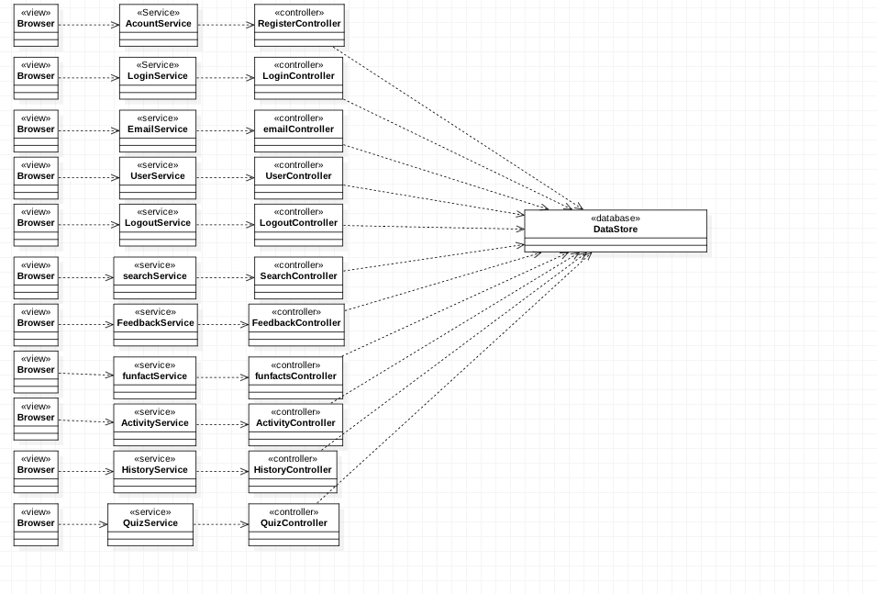

Figure # A.1- Caption Text

### Dynamic UML Diagrams

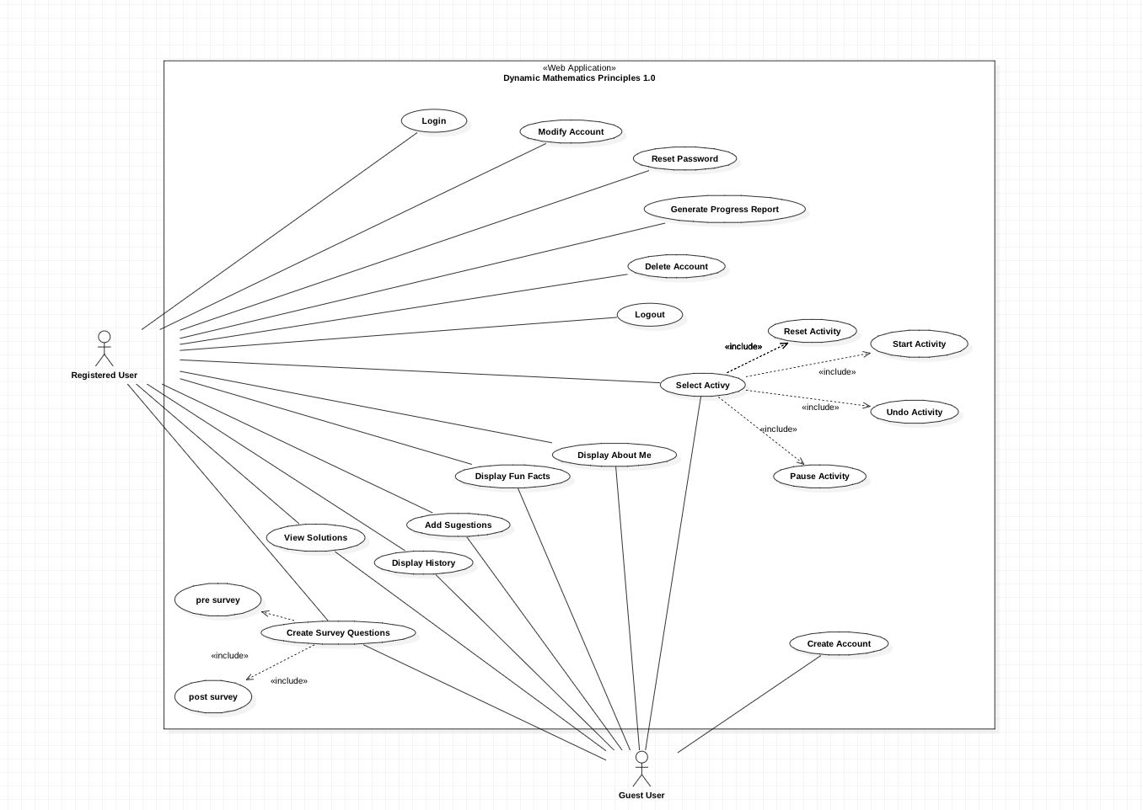

Figure # A.2- Use Case Model

**User Story # 666 - Register Account**

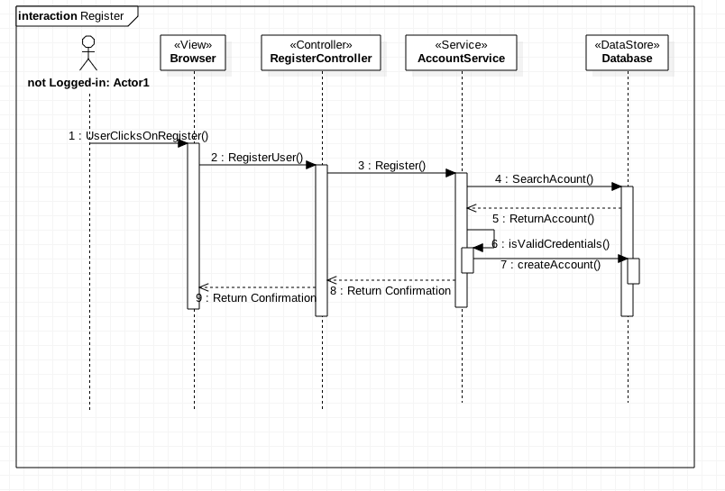

Figure # A.3- Register Account

**User Story #668 - Login**

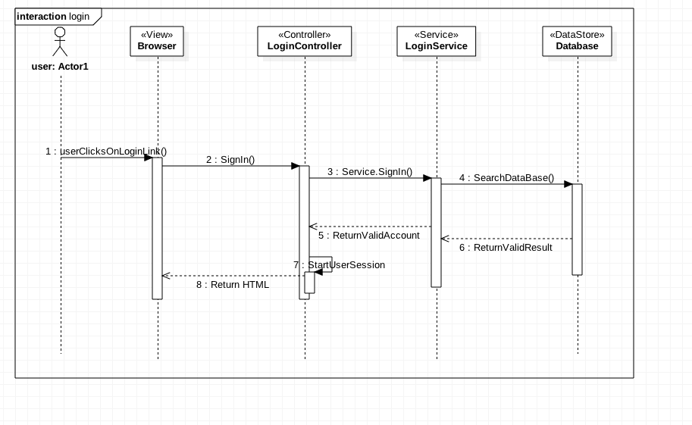

Figure #A.4 - Login Account

**User Story # 672 -Logout**

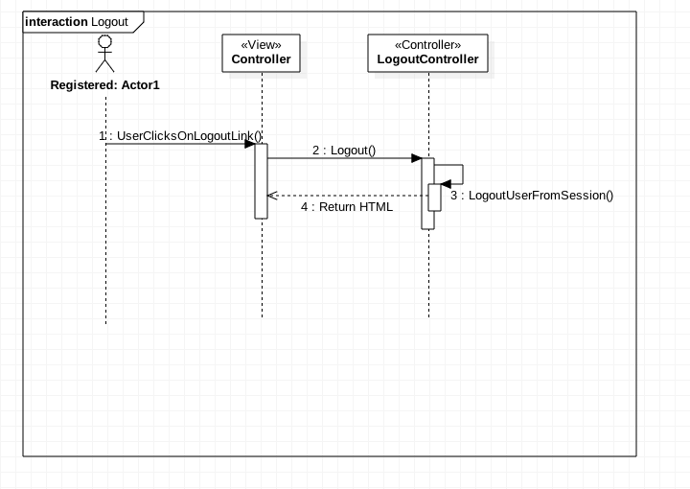

Figure #A.5 - Logout Account

**User Story #694 - Create Guest Session**

## 

## guest_accout.PNG

Figure # A.6- Create Guest Session

**User Story #674 - Reset Password**

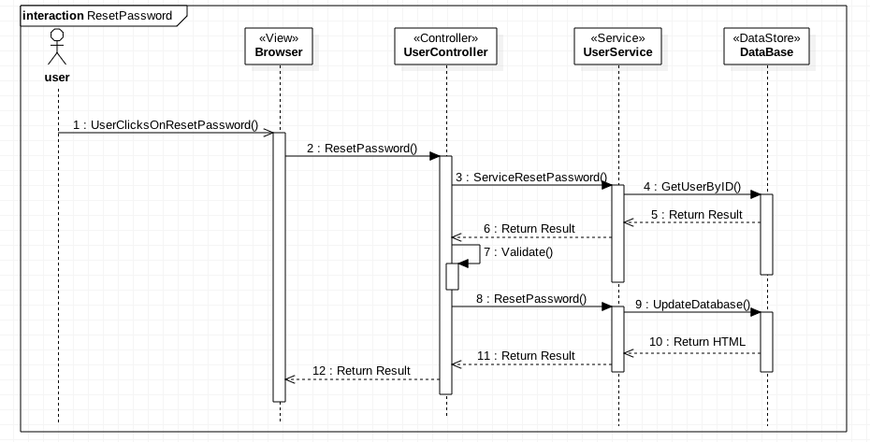

Figure #A.7 - Reset Password

**User Story #683 - Select Activity**

## 

## Select Activity Sequence Diagram.png

Figure #A.8 - Select Activity

**User Story #671 - Modify Account**

## Modify Account sequence diagram.PNG

Figure #A.9 - Modify Account

## 

## User Story#702 - Search

## SearchBar sequence diagram.png

Figure # A.10- Search Feature

**User Story #703 - Verify Account**

## verifyAccountSequenceDiagram.png

Figure #A.11 - Verify Account

**User Story #703 -Invariant Geometry Page**

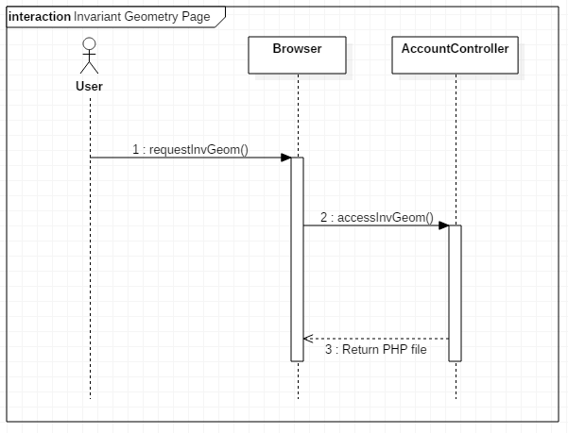

Figure #A.12 -Invariant Geometry Page

**User Story #731 -About Us Page**

## 

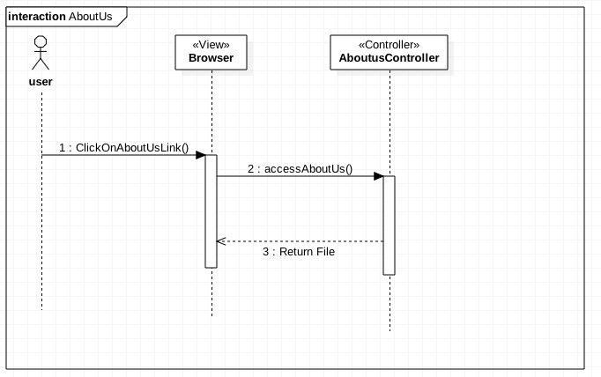

Figure # A.13- About Us page

**User Story #730 -Suggestions Page**

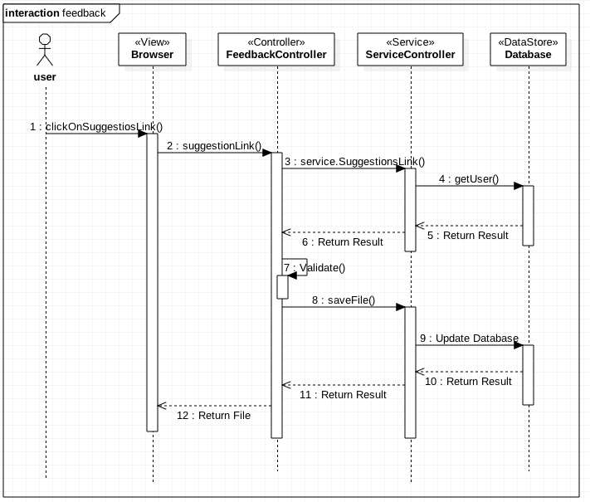

Figure #A.14 - Suggestions page

**User Story #686 -Fun Facts Page**

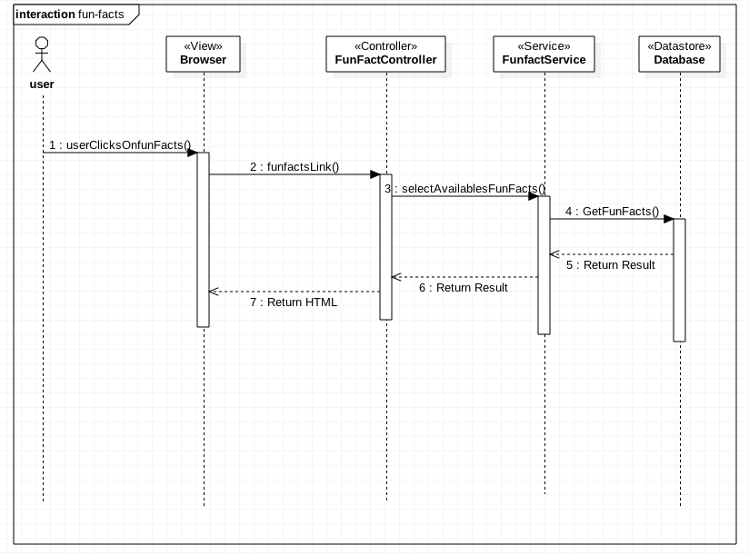

Figure #A.15 - Fun-facts page

**User Story #686 -History Page**

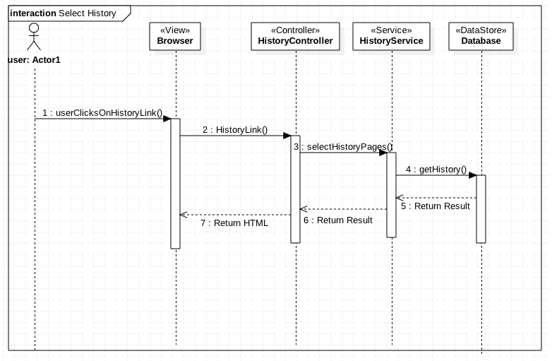

Figure #A.16 -History Page

**User Story #736 - Select Survey page**

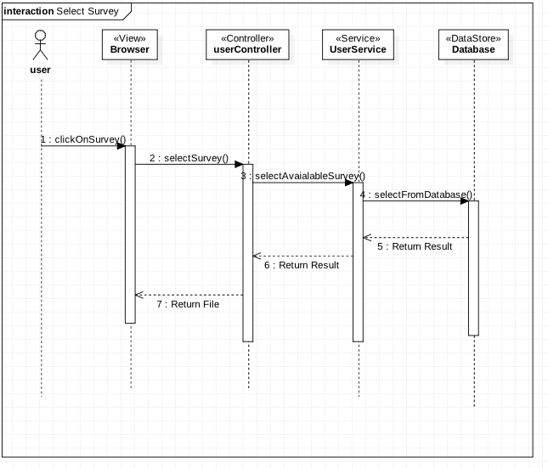

Figure #A.17 - Select Survey Page

**User Story #735 -Delete user Account**

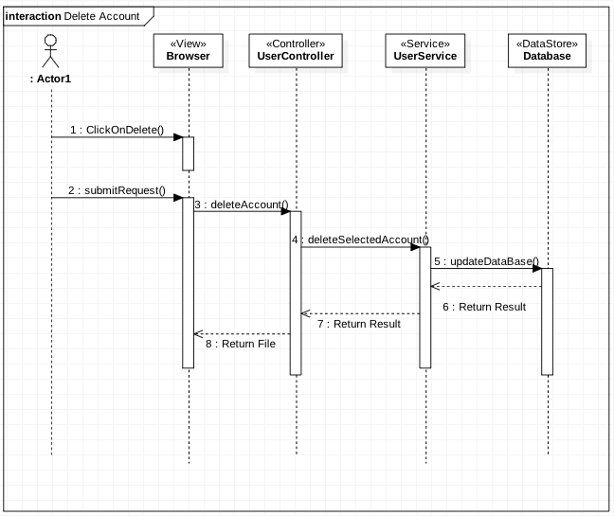

Figure #A.18 - Delete Account

**User Story #741 -Create Rating page**

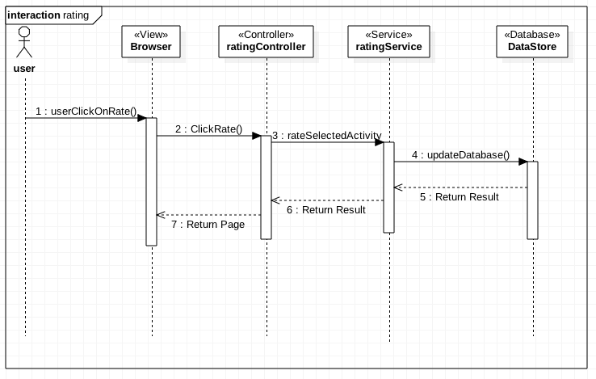

Figure # A.19- Rating page

**User Story #735 -Visitor Counter**

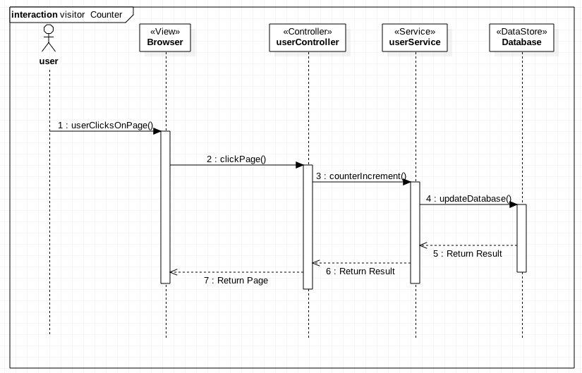

Figure # A.20- Visitor Counter

**User Story #735 -Dynamic Activity Triangle Area**

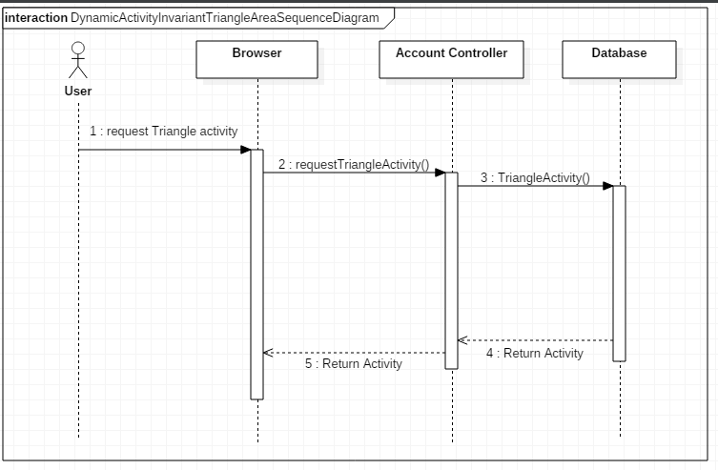

Figure #A.21 - Dynamic Activity Triangle Area

**User Story #735 -Dynamic Activity Infinity**

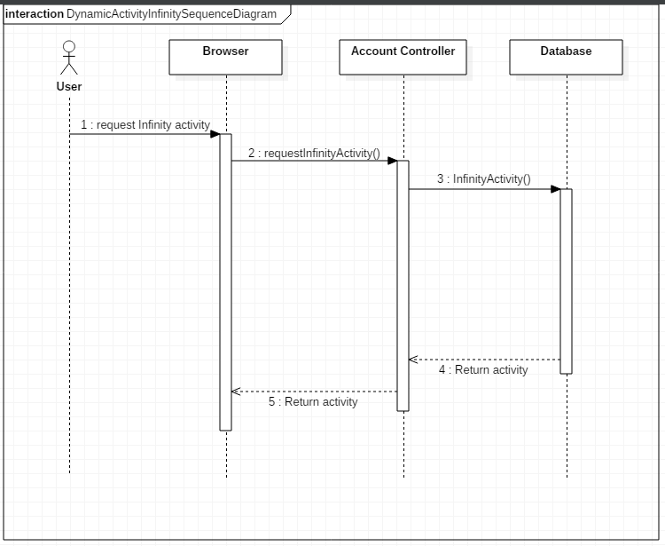

Figure #A.22 - Dynamic Activity Infinity

**User Story #744 -Create Archimedes Activity Quiz**

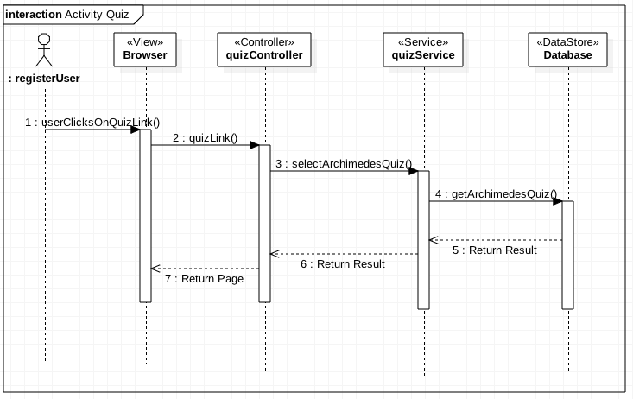

Figure #A.23 - Archimedes Activity Quiz

**User Story #745 - Create Activity quiz CarlFrederich**

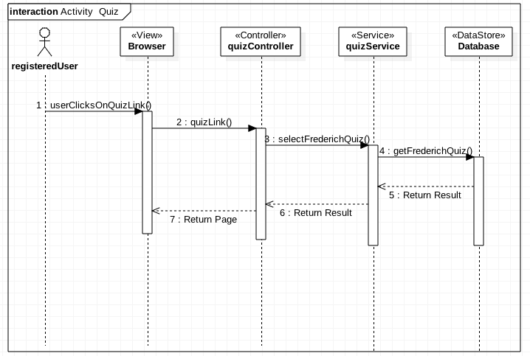

Figure # A.24- Carl Gauss Activity Quiz

**User Story #746 - Create Activity quiz Invariant Geometry**

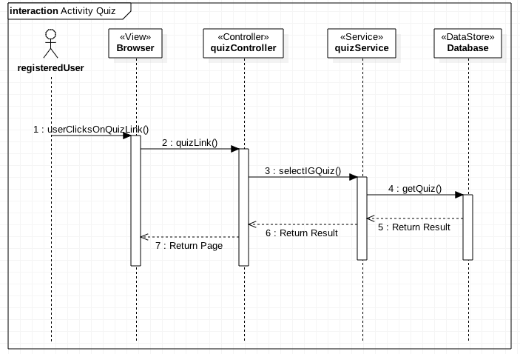

Figure #A.25 - Invariant Geometry Quiz

**User Story #747 - Create Infinity Activity Quiz**

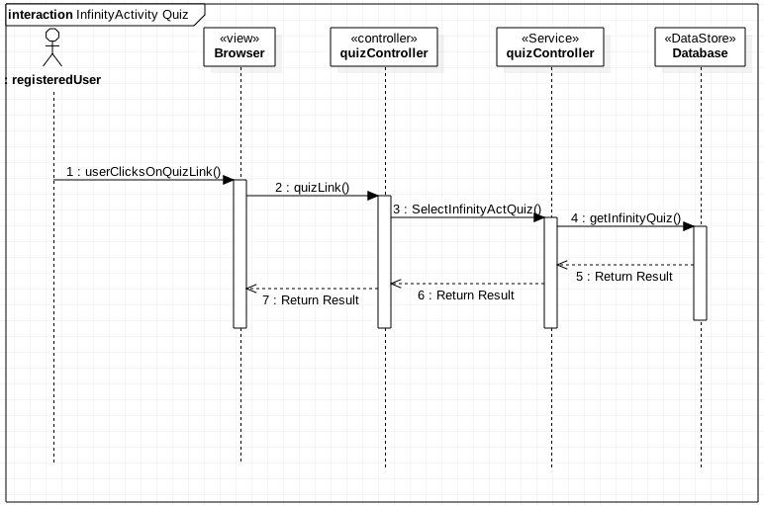

Figure #A.26 - Infinity Activity Quiz

**User Story #748 - Create Triangle Activity Quiz**

## triangleActivityQuiz.png

Figure # A.27- Triangle Activity Quiz

**User Story #753 - Create Final Behavioral survey**



Figure # A.28- Final survey

**User Story #750 - Create Hints**

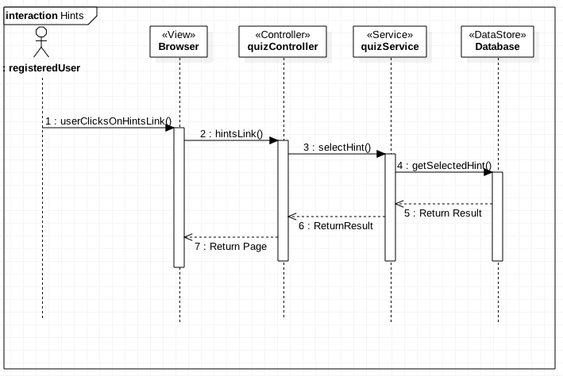

Figure # A.29- Create Hints

## 

## Appendix B - User Interface Design

Include screenshots of the user interface of your system. For new versions of existing systems, include only screenshots of the new or modified aspects of the user interface.

There’s no need for introducing this section.

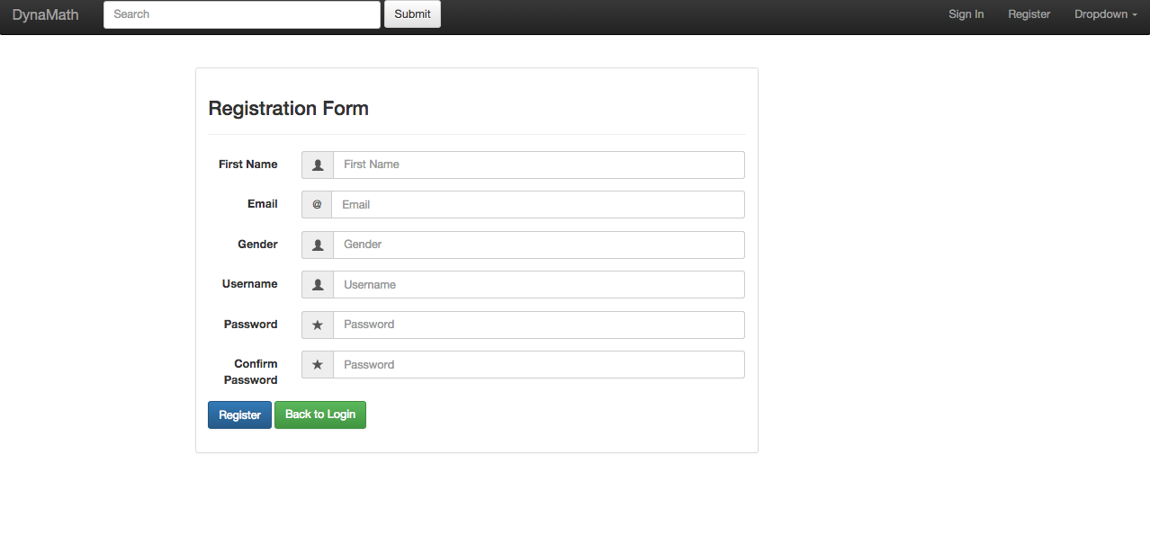

Figure # B.1- Registration Form

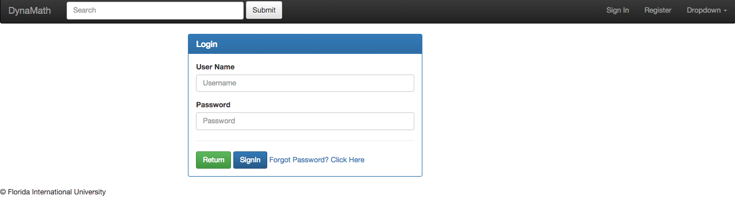

Figure #B.2 - Login page

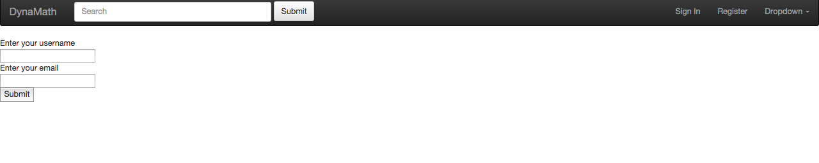

Figure #B.3 -Forgot Password

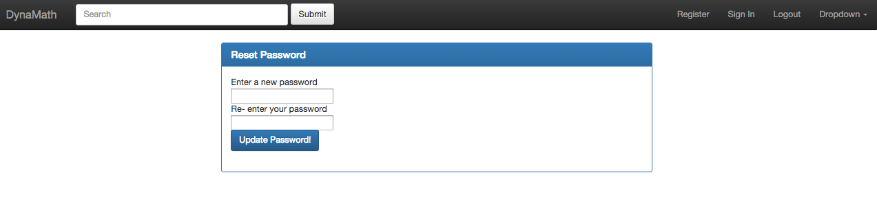

Figure #B.4- Reset Password

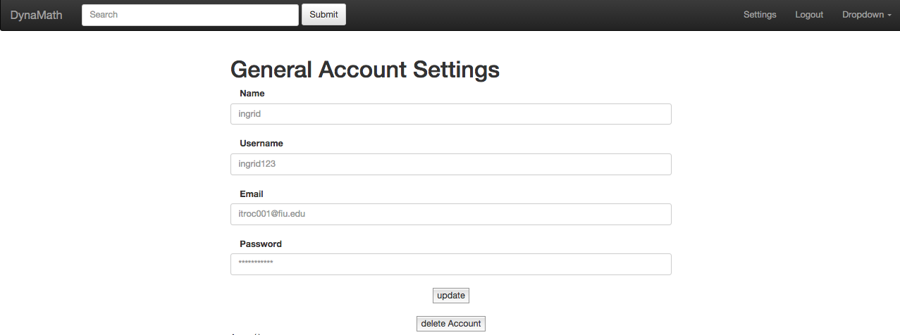

Figure # B.5 - Account Settings

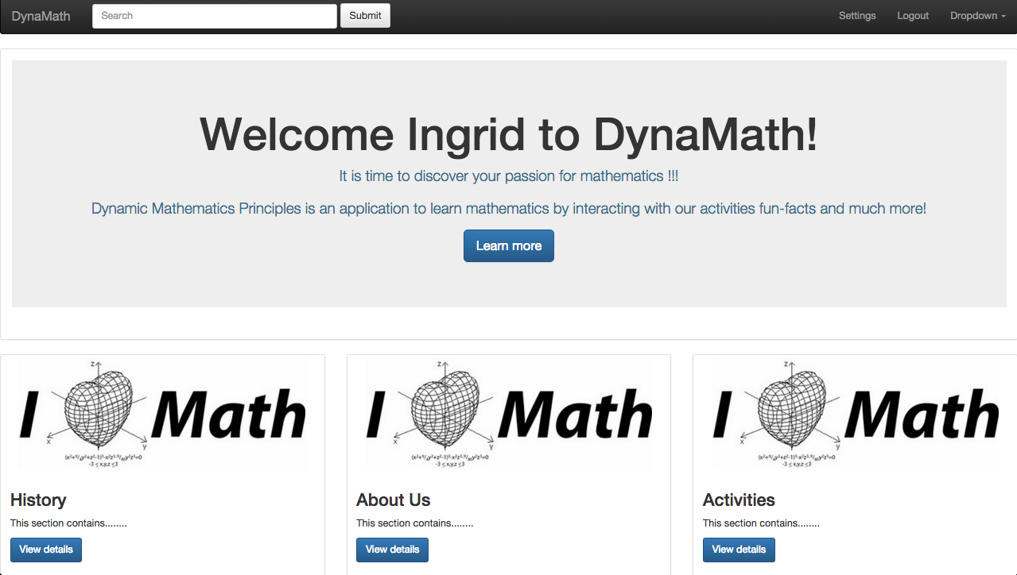



Figure #B.6 - User Page

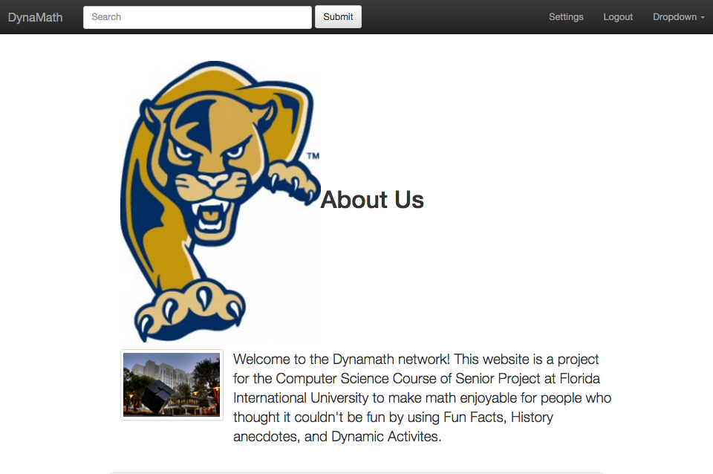



Figure # B.7- About Us page

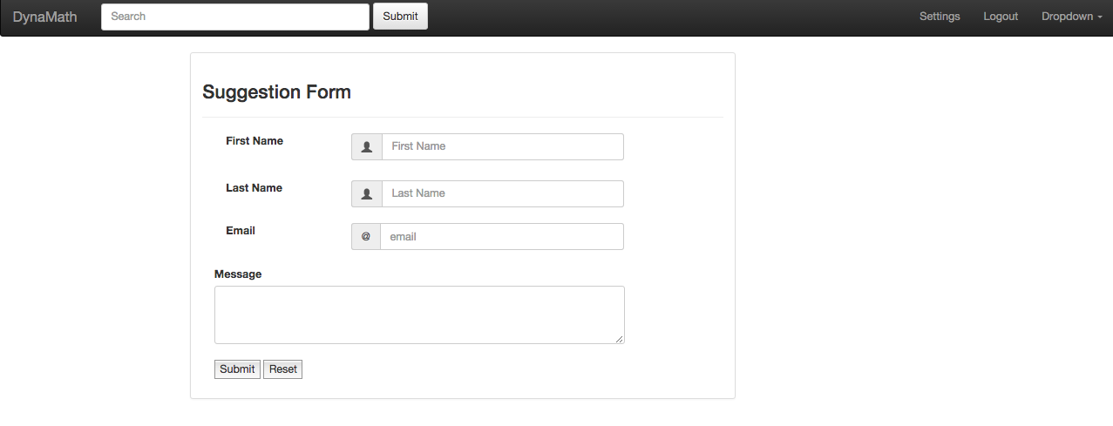

Figure # B.8- Suggestions Page

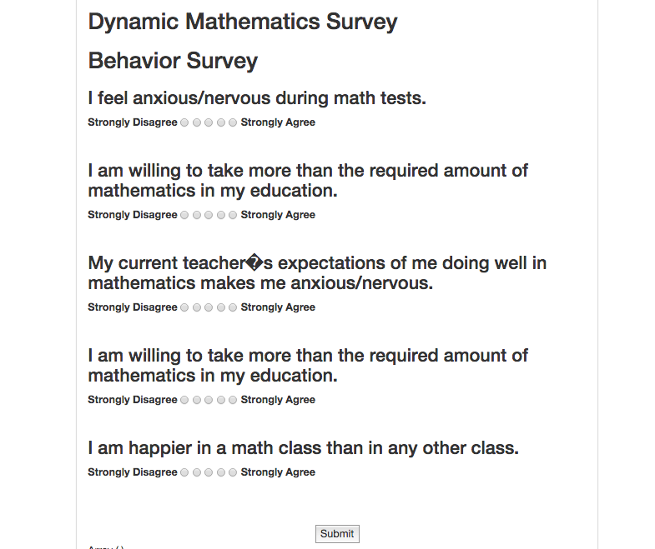

Figure #B.9 - Survey Page

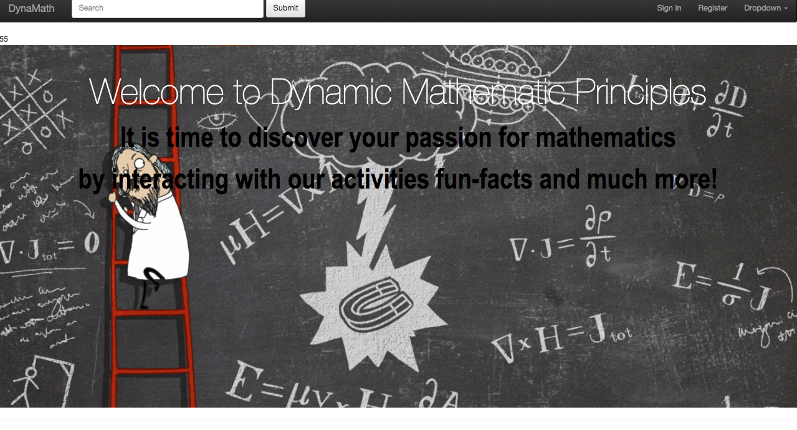

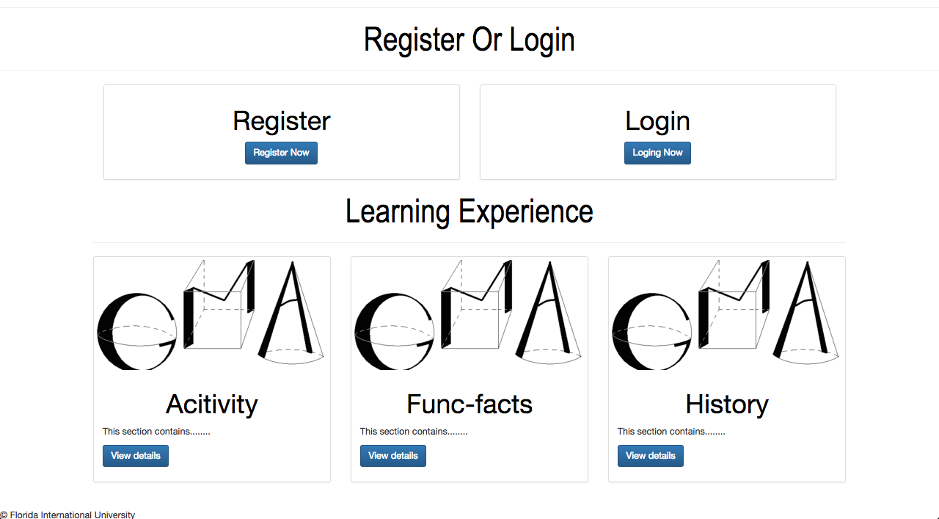

Figure # - HomePage

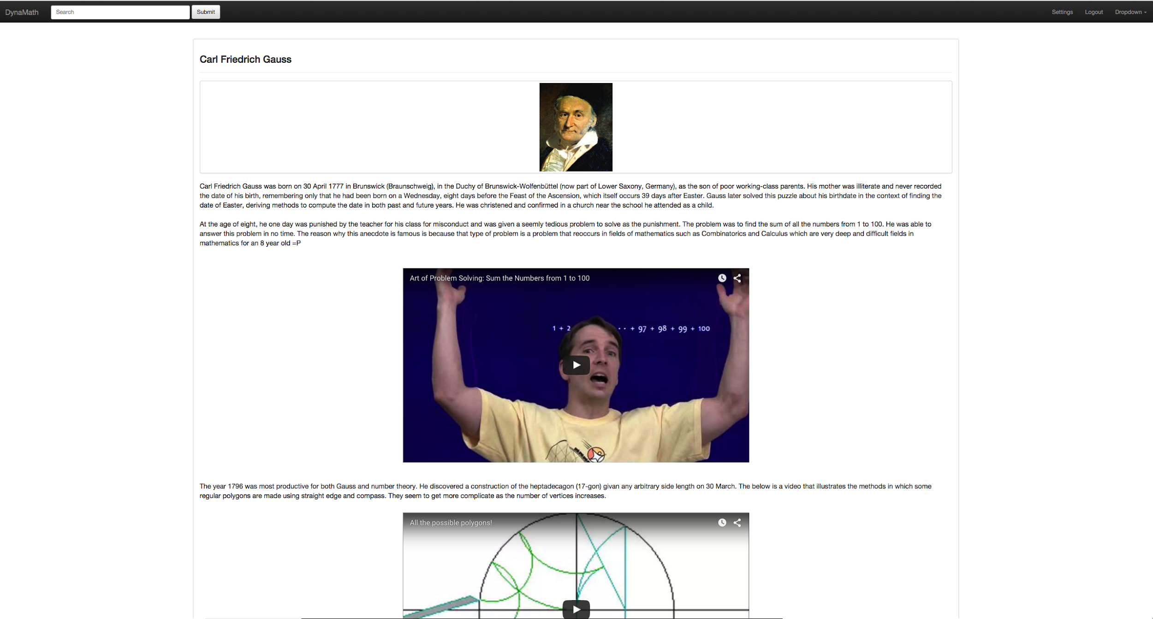

Figure #B.12 -Archimedes history page

## archimedesScreenShot.png

Figure #B.11 - Gauss History Page

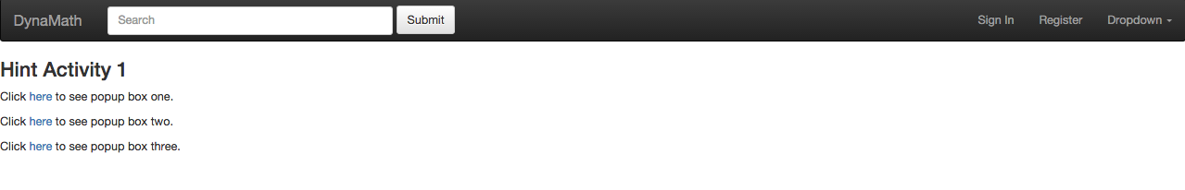

Figure #B.12 - Select Hint

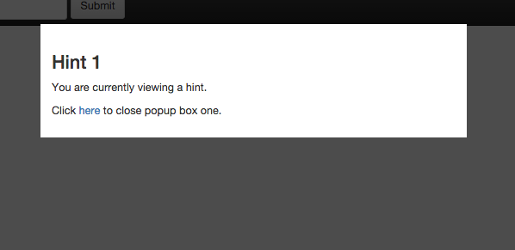

Figure #B.13- Hint PopUp window

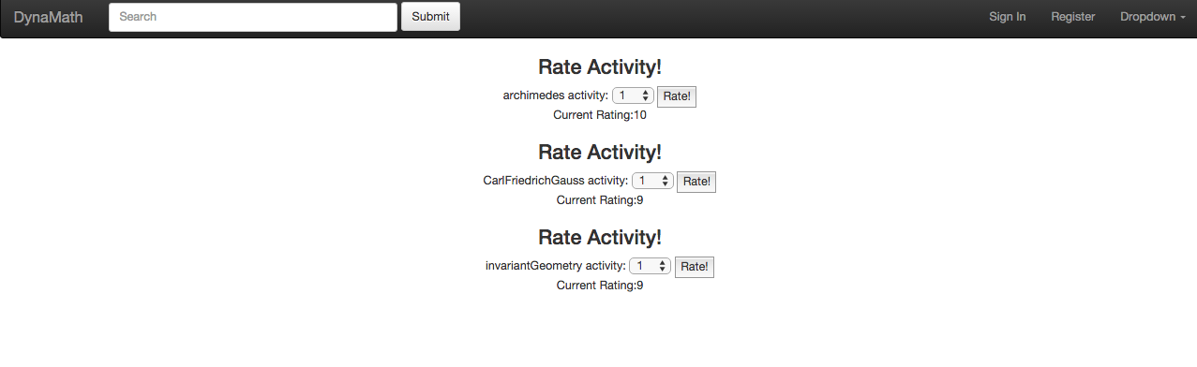

Figure #B.14- Ratings

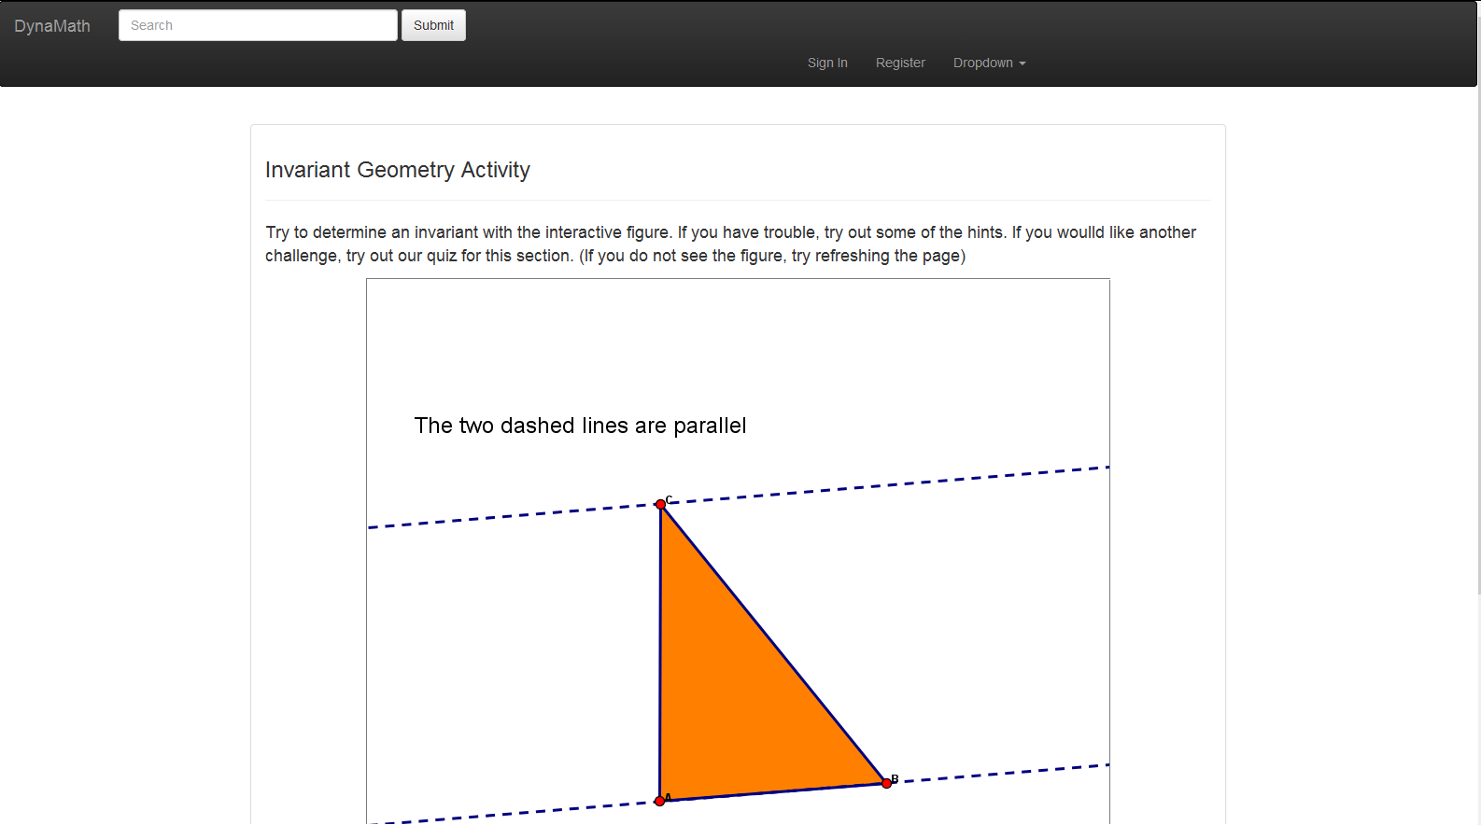

Figure #B.15- Invariant Geometry

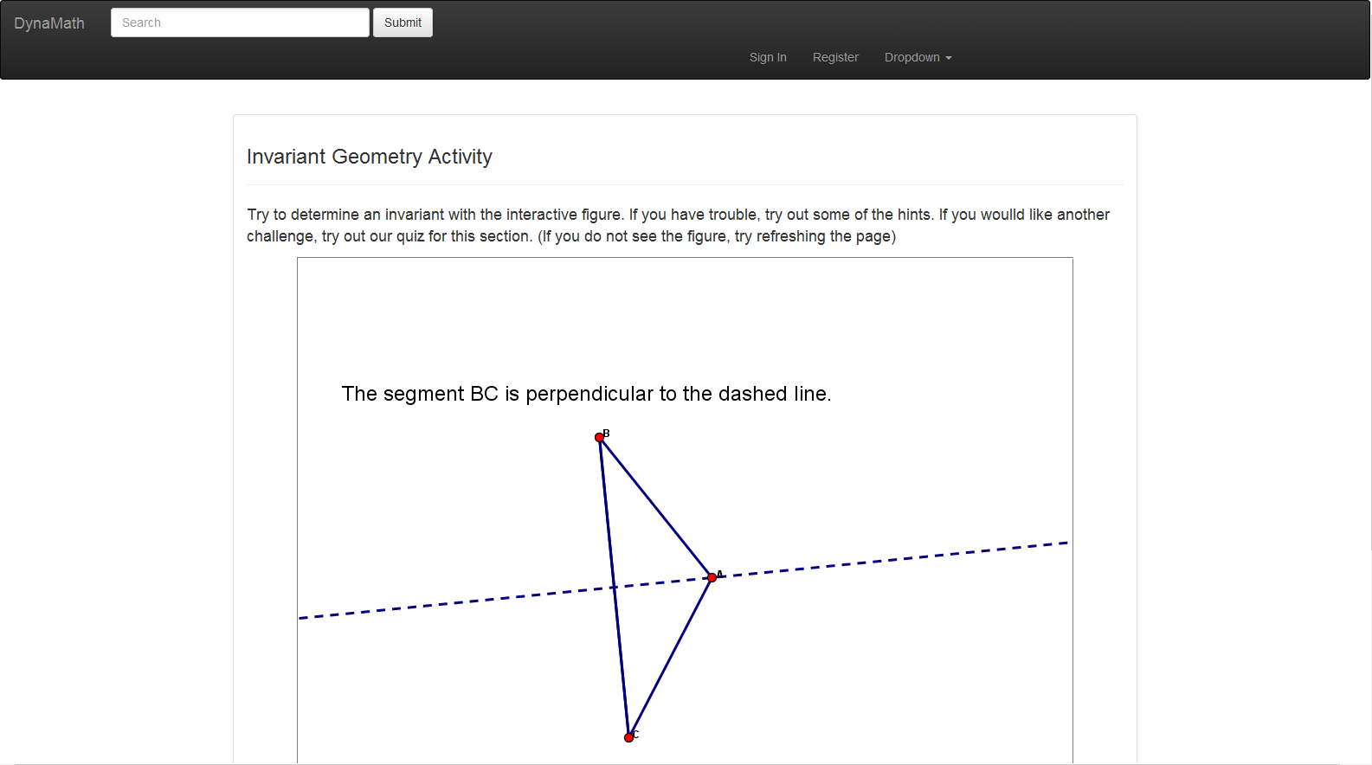

Figure #B.16- Invariant Geometry

## Appendix C - Sprint Review Reports

**Sprint 1 Report**

**Date:** August 26, 2015.

**Attendees:** Andres M. Cubas, Ingrid Troche, Mario Eraso,Dr. Masoud Sadjadi

**Discussed Topics:**

Achieved:

* Collected all user stories successfully
* Created Mingle account and placed user stories on the backlog
* Requested and installed VM phpmyadmin
* Created use case diagram, sequence diagrams for register, login,logout, guest user
* Created documentation
* Created login frontend and backend
* Created registration frontend and backend
* Created logout backend
* Create Guest user backend

**Sprint 2 Report**

**Date:** September 26, 2015.

**Attendees:** Andres M. Cubas, Ingrid Troche, Mario Eraso, Dr. Masoud Sadjadi

**Discussed Topics:**

Achieved:

* Updated Mingle account and placed user stories on the backlog
* Requested JSP software
* Created use case diagram, sequence diagrams
* Updated documentation
* Created reset password frontend and backend
* Created fun-facts frontend and backend
* Created verify account backend

**Sprint 3 Report**

**Date:** October 9, 2015.

**Attendees:** Andres M. Cubas, Ingrid Troche, Mario Eraso,Dr.Masoud Sadjadi

**Discussed Topics:**

Achieved:

* Updated Mingle account and placed user stories on the backlog
* Requested JSP software
* Created use case diagram, sequence diagrams
* Updated documentation
* Created about Us front end
* Created fun-facts frontend and backend
* Created feedback frontend and backend
* Created Modify account frontend and backend

**Sprint 4 Report**

**Date:** October 23, 2015.

**Attendees:** Andres M. Cubas, Ingrid Troche, Mario Eraso,Dr.Masoud Sadjadi

**Discussed Topics:**

Achieved:

* Updated Mingle account and placed user stories on the backlog
* Created use case diagram, sequence diagrams
* Updated documentation
* Created Behavioral Survey frontend and backend
* Created fun-facts infinity frontend and backend
* Created delete account backend
* Created Archimedes Questionnaire front end
* Created page for guest users and login

**Sprint 5 Report**

**Date:** November 5, 2015.

**Attendees:** Andres M. Cubas, Ingrid Troche, Mario Eraso,Dr.Masoud Sadjadi

**Discussed Topics:**

Achieved:

* Updated Mingle account and placed user stories on the backlog
* Created use case diagram, sequence diagrams
* Updated documentation
* Created Behavioral Password Hashing backend
* Created dynamic Activity Triangle Area frontend and backend
* Created dynamic Activity Infinity frontend and backend
* Created visitor counter backend
* Created rating page frontend and backend
* Added table for visitor and ratings to record information

**Sprint 6 Report**

**Date:** November 20, 2015.

**Attendees:** Andres M. Cubas, Ingrid Troche, Mario Eraso,Dr.Masoud Sadjadi

**Discussed Topics:**

Achieved:

* Updated Mingle account and placed user stories on the backlog
* Created use case diagram, sequence diagrams
* Updated documentation
* Created for each quiz backend
* Create front end for each quiz
* Added table for database to store quiz scores and questions
* Create backend for infinity Activity quiz
* Create backend for Triangle Activity quiz

**Sprint 7 Report**

**Date:** Dec 04, 2015.

**Attendees:** Andres M. Cubas, Ingrid Troche, Mario Eraso,Dr.Masoud Sadjadi

**Discussed Topics:**

Achieved:

* Updated Mingle account and placed user stories on the backlog
* Created use case diagram, sequence diagrams
* Updated documentation
* Moved system into the server
* Create frontend and backend for hints
* Added table for database to store hints
* Create backend and frontend for final survey

**Sprint 1 Retrospective**

**Date:** Month Day, Year

**Attendees:** Ingrid Troche,Andres M. Cubas, Dr.Masoud Sadjadi

**Discussed Topics:**

The team was able to meet on time and attend to all meetings. We were able to complete the features requested by our product owner. We were able to work on documentation, UML diagrams, feasibility, requirements and testing. As a result, we were all satisfied with the work done on sprint 1 and moved on to sprint 2. In order to improve in future sprints, we will take more time for testing and reflected in our user stories.

**Sprint 2 Retrospective**

**Date: 09/25/2015**

**Attendees:** Ingrid Troche, Andres M.Cubas, Dr, Masoud Sadjadi

**Discussed Topics:**

The team was able to meet on time and attend to all meetings. We were able to complete the features requested by our product owner. We were able to work on documentation, UML diagrams, feasibility, requirements and testing. As a result, we were all satisfied with the work done on sprint 2 and moved on to sprint 3. In order to improve in future sprints, we will take more time for documentation and testing and reflected in our user stories.

**Sprint 3 Retrospective**

**Date: 10/09/2015**

**Attendees:** Ingrid Troche, Andres M.Cubas, Dr, Masoud Sadjadi

**Discussed Topics:**

The team was able to meet on time and attend to all meetings. We were able to complete the features requested by our product owner. We were able to work on documentation, UML diagrams, feasibility, requirements and testing. As a result, we were all satisfied with the work done on sprint 3 and moved on to sprint 4. In order to improve in future sprints, we will take more time for documentation and testing and reflected in our user stories.

**Sprint 4 Retrospective**

**Date: 10/23/2015**

**Attendees:** Ingrid Troche, Andres M.Cubas, Dr, Masoud Sadjadi

**Discussed Topics:**

The team was able to attend to all meetings. We were able to complete the features requested by our product owner. We were able to work on documentation, coding and testing. As a result, we were all satisfied with the work done on sprint 4 and moved on to sprint 5. In order to improve in future sprints, we will take more time for testing and reflected in our user stories.

**Sprint 5 Retrospective**

**Date: 11/06/2015**

**Attendees:** Ingrid Troche, Andres M.Cubas, Dr, Masoud Sadjadi

**Discussed Topics:**

The team was able to attend to all meetings. We were able to complete the features requested by our product owner. We were able to work on documentation, coding and testing. As a result, we were all satisfied with the work done on sprint 5 and moved on to sprint 6. In order to improve in future sprints, we will take more time for documentation.

**Sprint 6 Retrospective**

**Date: 11/06/2015**

**Attendees:** Ingrid Troche, Andres M.Cubas, Dr, Masoud Sadjadi

**Discussed Topics:**

The team was able to attend to all meetings. We were able to complete the features requested by our product owner. We were able to work on documentation, coding and testing. As a result, we were all satisfied with the work done on sprint 6 and moved on to sprint 7. In order to improve in future sprints, we will take more time for testing.

# 

**Sprint 7 Retrospective**

**Date: 11/06/2015**

**Attendees:** Ingrid Troche, Andres M.Cubas, Dr, Masoud Sadjadi

**Discussed Topics:**

The team was able to attend to all meetings. We were able to complete the features requested by our product owner. We were able to work on documentation, coding and testing. As a result, we were all satisfied with the work done on sprint 7. In order to improve in future sprints, we will take more time for testing.

# References

You must reference any work that is not your own.